**Private Facebook Page**

*Bryan*:

Hi all! I’m happy to let you know that I’m running for student body president with Nidia Ruelas this week! If you’re interested, like my page, and feel free to contact me with any questions you might have! Don’t forget to vote Wed. Feb. 4th

If you haven’t yet, please check out my campaign page! I’d appreciate your support and vote on Wed. Feb. 4th. Contact me if you have any questions! *attach the Ricketts Ruelas 2015 FB page*

It’s election day! Thank you to all the people who have worked with the Ricketts Ruelas 2015 team over the past week. Please be sure to go to jcouncil.nd.edu/vote to cast your ballot (only once!) and contact me if you’ve got any last minute questions! *attach the Ricketts Ruelas 2015 FB page*

PrismND & OUTreach Facebook Group: Hi all! As you may have heard, I’m running for student body president. I have really enjoyed serving as your president for the past two years, and regardless of the outcome of this election, I will serve out my term with you all. My running mate, Nidia Ruelas, and I hope you will consider voting for us on Wed. Feb. 4th. Please feel free to check out our platform and contact us if you have any questions. *attach the Ricketts Ruelas 2015 FB page*

Chemical Engineering/Engineering Facebook Group:Hi CHEGs! As you may have heard, I’m running for student body president! Don’t worry, I’m still staying in engineering, but my running mate, Nidia Ruelas, and I hope you’ll consider voting for us on Wed. Feb. 4th. Please feel free to check out our platform and contact us if you have any questions! *attach the Ricketts Ruelas 2015 FB page*

*Nidia*:

Hello everyone! I am happy to announce that I am running for Student Body Vice President with Bryan Ricketts. If you would LOVE to hear more, please LIKE our facebook page at *FB page address* for more information, updates, and more contact information. And always feel free to reach out to me if you have any questions! Oh and don’t forget to vote on Election Day Wednesday, Feb. 4th. #RickettsRuelas2015

Whether you are procrastinating or just catching up with friends on Facebook, take a quick break and check out our platform on our campaign page and website!

FB Page:

Website:

Contact me with any thoughts, questions, or concerns! #RickettsRuelas2015

Ladies and gents, it is Election Day! Thank you to all who have worked with us this past week! It has been a wonderful experience. Make sure to vote TODAY anytime between 8am and 8pm EST!!! The link to the ballot may be found at jcouncil.nd.edu/vote. Contact me with any last minute questions! #RickettsRuelas2015

ND Famila:

Hola familia! As you may have heard, I am running for Student Body Vice President with Bryan Ricketts. For more information, make sure to visit our FB Page at *FB Page address* and do not hesitate to reach out to me with any comments or questions! Elections will be Wed. Feb. 4th so make sure to cast your vote! #RickettsRuelas2015

Lyons Hall:

Hello dearest Lyonites! I am happy to announce to you all that I am running for Student Body Vice President with Bryan Ricketts. For more information on us and our ideas, make sure to LIKE our FB Page at *FB Page address* and come to me with any questions or concerns. I’d be happy to answer any! Voting will take place on Wednesday, February 4th so make sure to cast your vote! #RickettsRuelas2015

Welsh Family Hall:

Hello Whirlwind ladies! As a former Whirlwind, I am happy to announce that I am running for Student Body Vice President with Bryan Ricketts. Please visit and like our Facebook page at *FB Page address* and reach out to me with any comments or questions. And remember to vote on Wednesday, February 4th! #RickettsRuelas2015

Domers in DC:

Hello all! As you may have heard, I am running for Student Body Vice President with Bryan Ricketts. For more information, make sure to visit our FB Page at *FB Page address* and do not hesitate to reach out to me with any comments or questions! Elections will be Wed. Feb. 4th so make sure to cast your vote! #RickettsRuelas2015

Student Coalition for Immigration Advocacy:

Hello! As you may have heard, I am running for Student Body Vice President with Bryan Ricketts. For more information, make sure to visit our FB Page at *FB Page address* and do not hesitate to reach out to me with any comments or questions! Elections will be Wed. Feb. 4th so make sure to cast your vote! #RickettsRuelas2015

November Freshman Retreat Leaders:

Hello! I am happy to announce that I am running for Student Body Vice President with Bryan Ricketts. For more information, make sure to visit our FB Page at *FB Page address* and do not hesitate to reach out to me with any comments or questions! Elections will be Wed. Feb. 4th so make sure to cast your vote! #RickettsRuelas2015

**Campaign Facebook Page**

**Day 1 (Tuesday):**

*FACEBOOK:*

12pm

Passion. Unity. Identity.

We’re very excited to announce our candidacy for the 2015 Student Body Presidential elections. We are looking forward to meeting each of you this week to share our vision for Notre Dame with you!

Please invite your friends to like this page, look for us around campus, and be sure to Vote Ricketts-Ruelas on February 4th! #RickettsRuelas2015

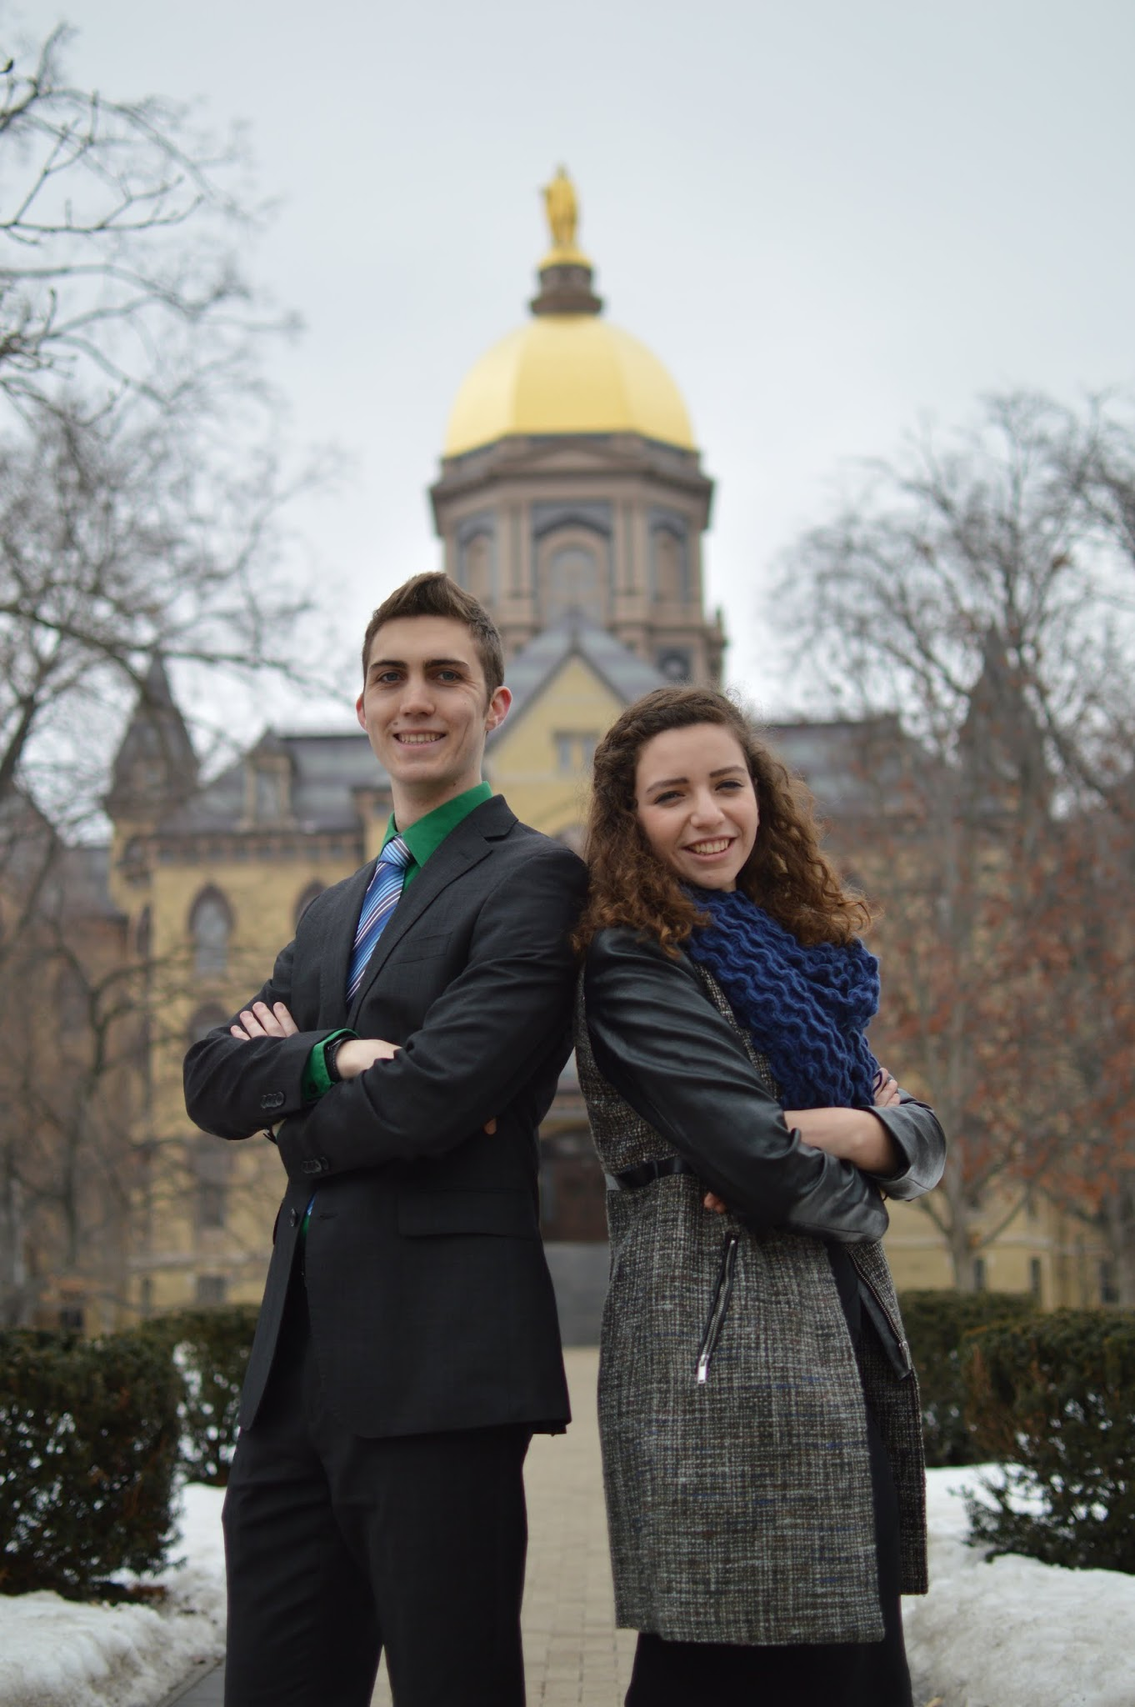 (DSC_1772)

12:30 PM

Check out our platform at nd.edu/~brickett

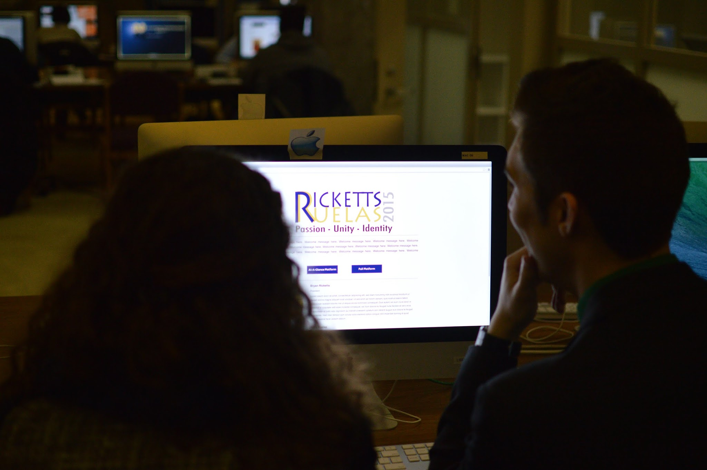 (DSC_1837)

1:30pm

Hi Notre Dame! My name is Bryan Ricketts and I’m a junior studying Political Science and Chemical Engineering while living in Duncan Hall. I started my work on Notre Dame’s campus as the president of PrismND from 2013-2015 and as a peer educator for the Gender Relations Center. My work in these roles has focused on creating spaces in which students are able to explore, grow, and challenge their identities, and which support all the members of the Notre Dame family. It has taken me to relationships with faculty, staff, and administrators which I plan to connect to passionate students in ways that will further their vision of Our Lady’s University. I looks forward to meeting each member of campus and hearing the story of their Notre Dame identity.

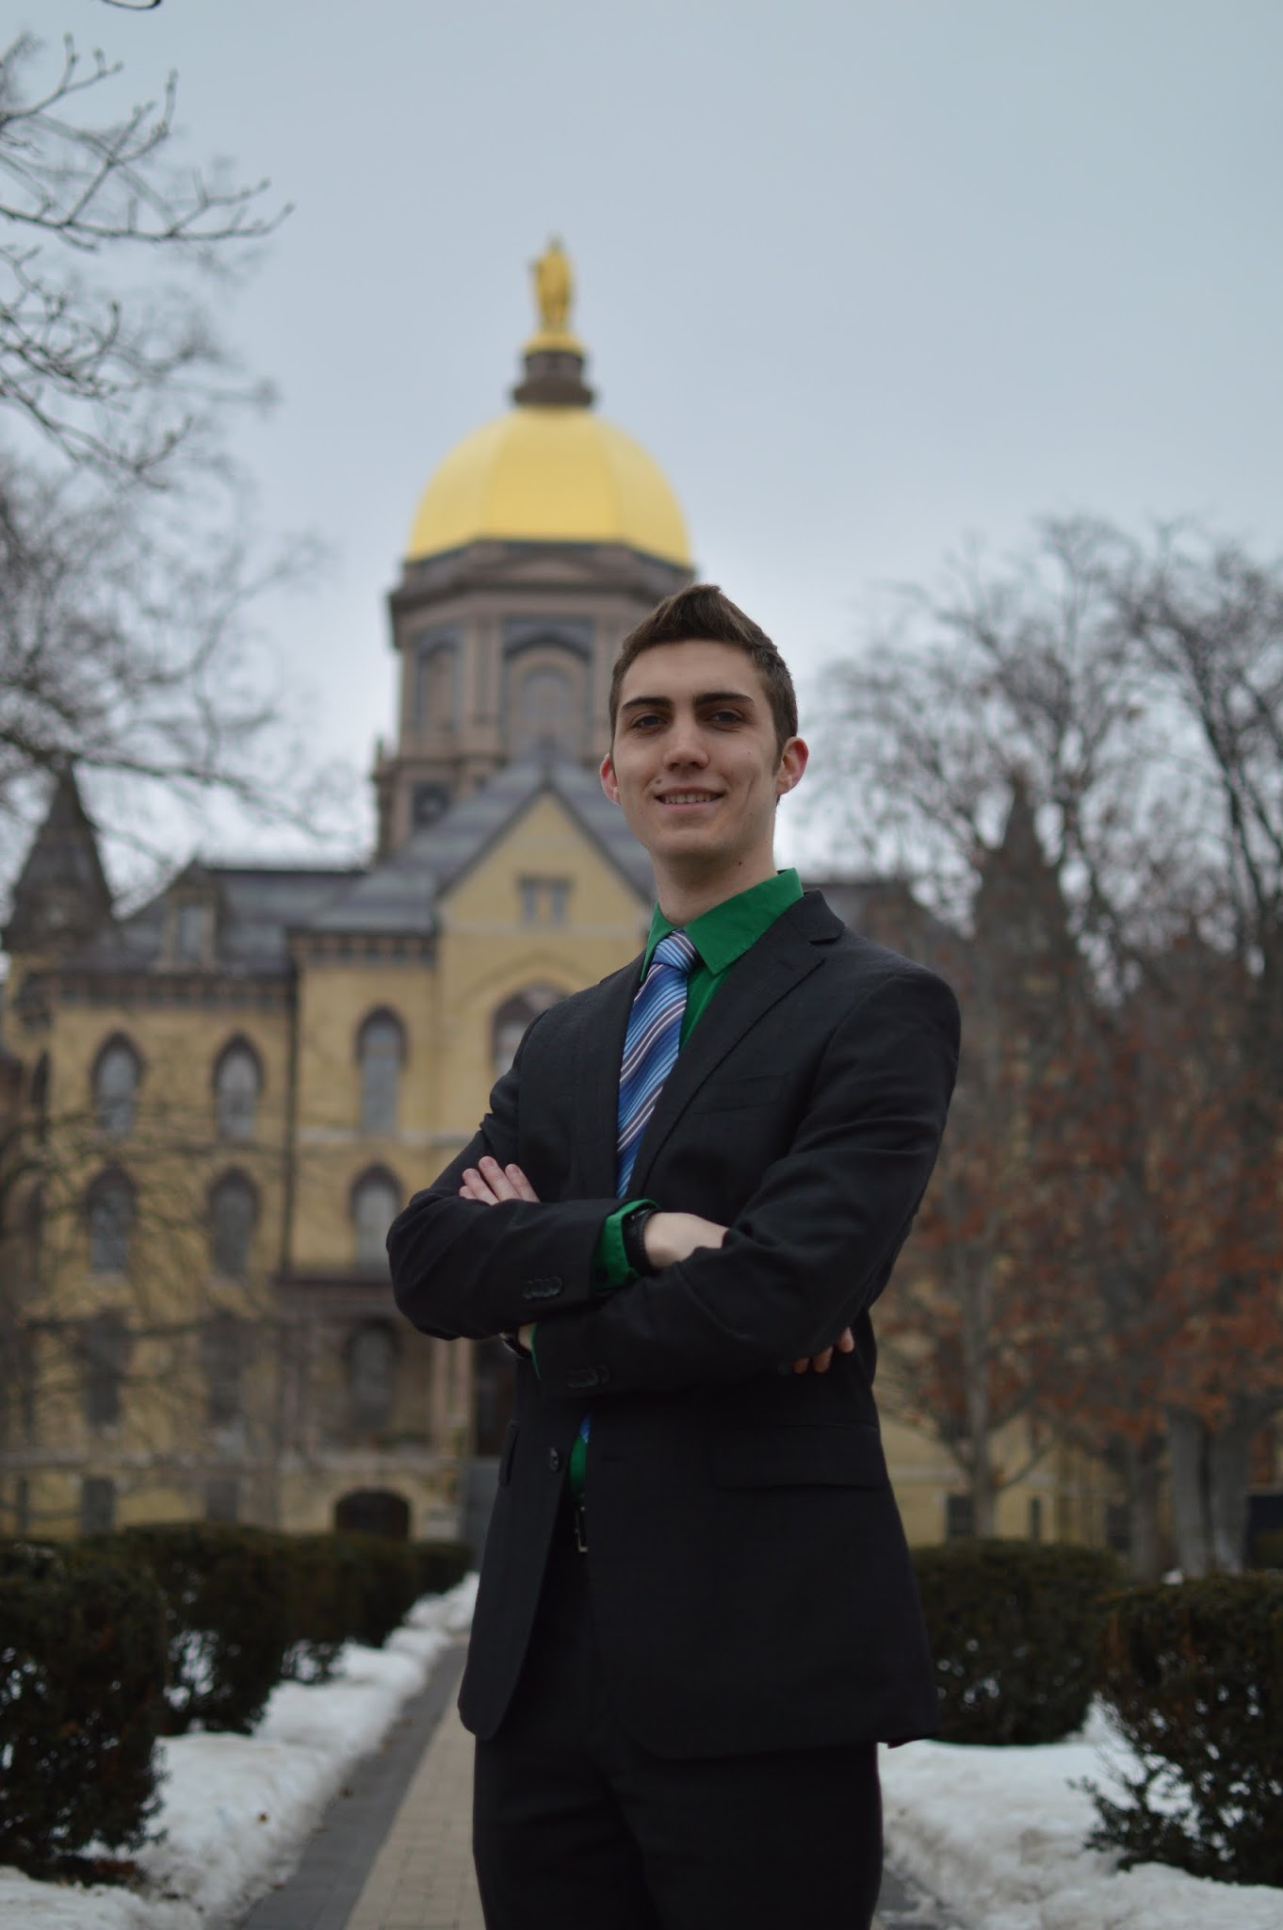 (DSC_1761)

3:30pm

Hello everyone! My name is Nidia Ruelas and I am a junior studying Political Science and French. Coming to Notre Dame all the way from California, I became involved in my dorm community in Welsh Family Hall early on in my time here at ND. By sophomore year I became involved in Diversity Council where most of my work takes place today. After a summer of research in D.C. and a semester abroad in France, I am back with a greater passion for engaging with the student body and improving student life. My vision for campus is a place of productive dialogue, motivating challenge, and collaborative action. It is my hope and mission to make this possible as well as to provide the space and opportunity to work together for a better Notre Dame. #RickettsRuelas2015

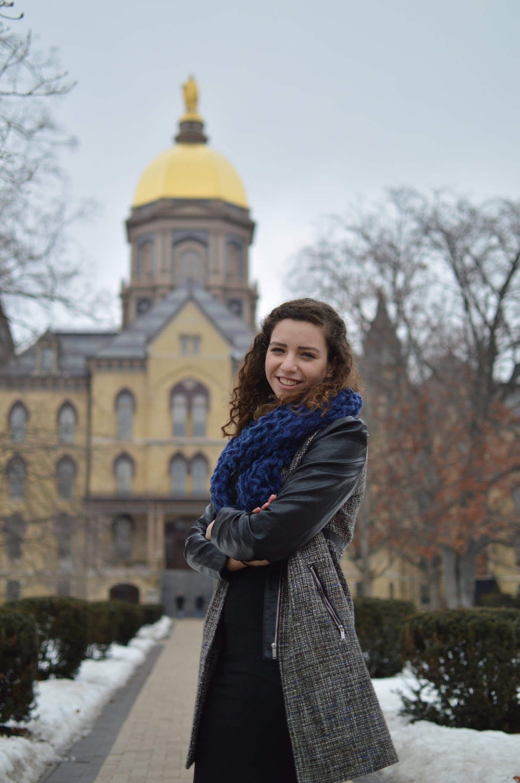 (DSC_1764)

5:30pm

Let’s sit down and have a conversation! We hope to have frequent personal contact with students through initiatives that bring student government members to dorms and clubs. #RickettsRuelas2015

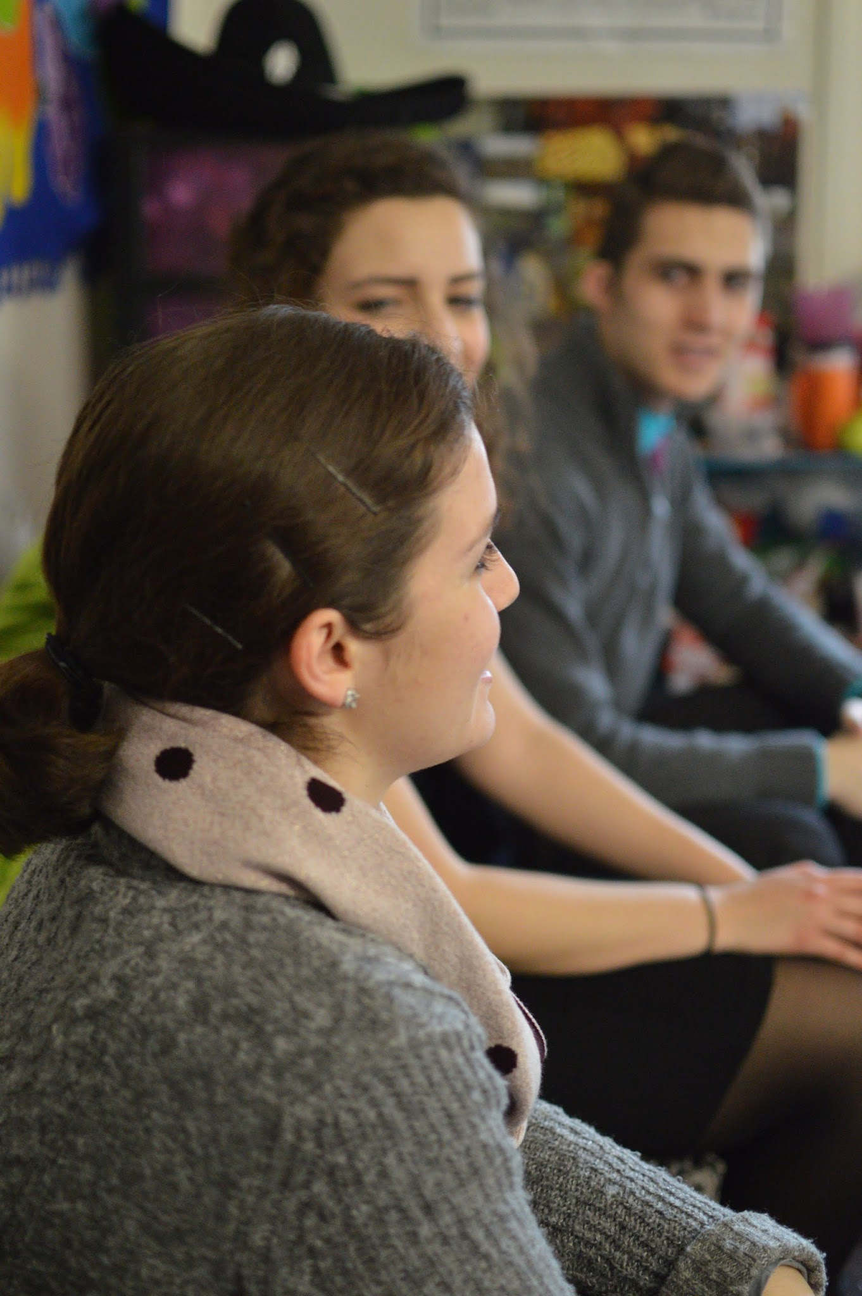 (DSC_1680)

tag Genevieve Lyons

8:30pm

You represent your dorm when you wear your apparel around campus - what if your same passion could fund the dorm events that make your community unique? We envision a week dedicated to celebrating the identities of all 29 dorms and helping them raise money to strengthen their unity. #RickettsRuelas2015

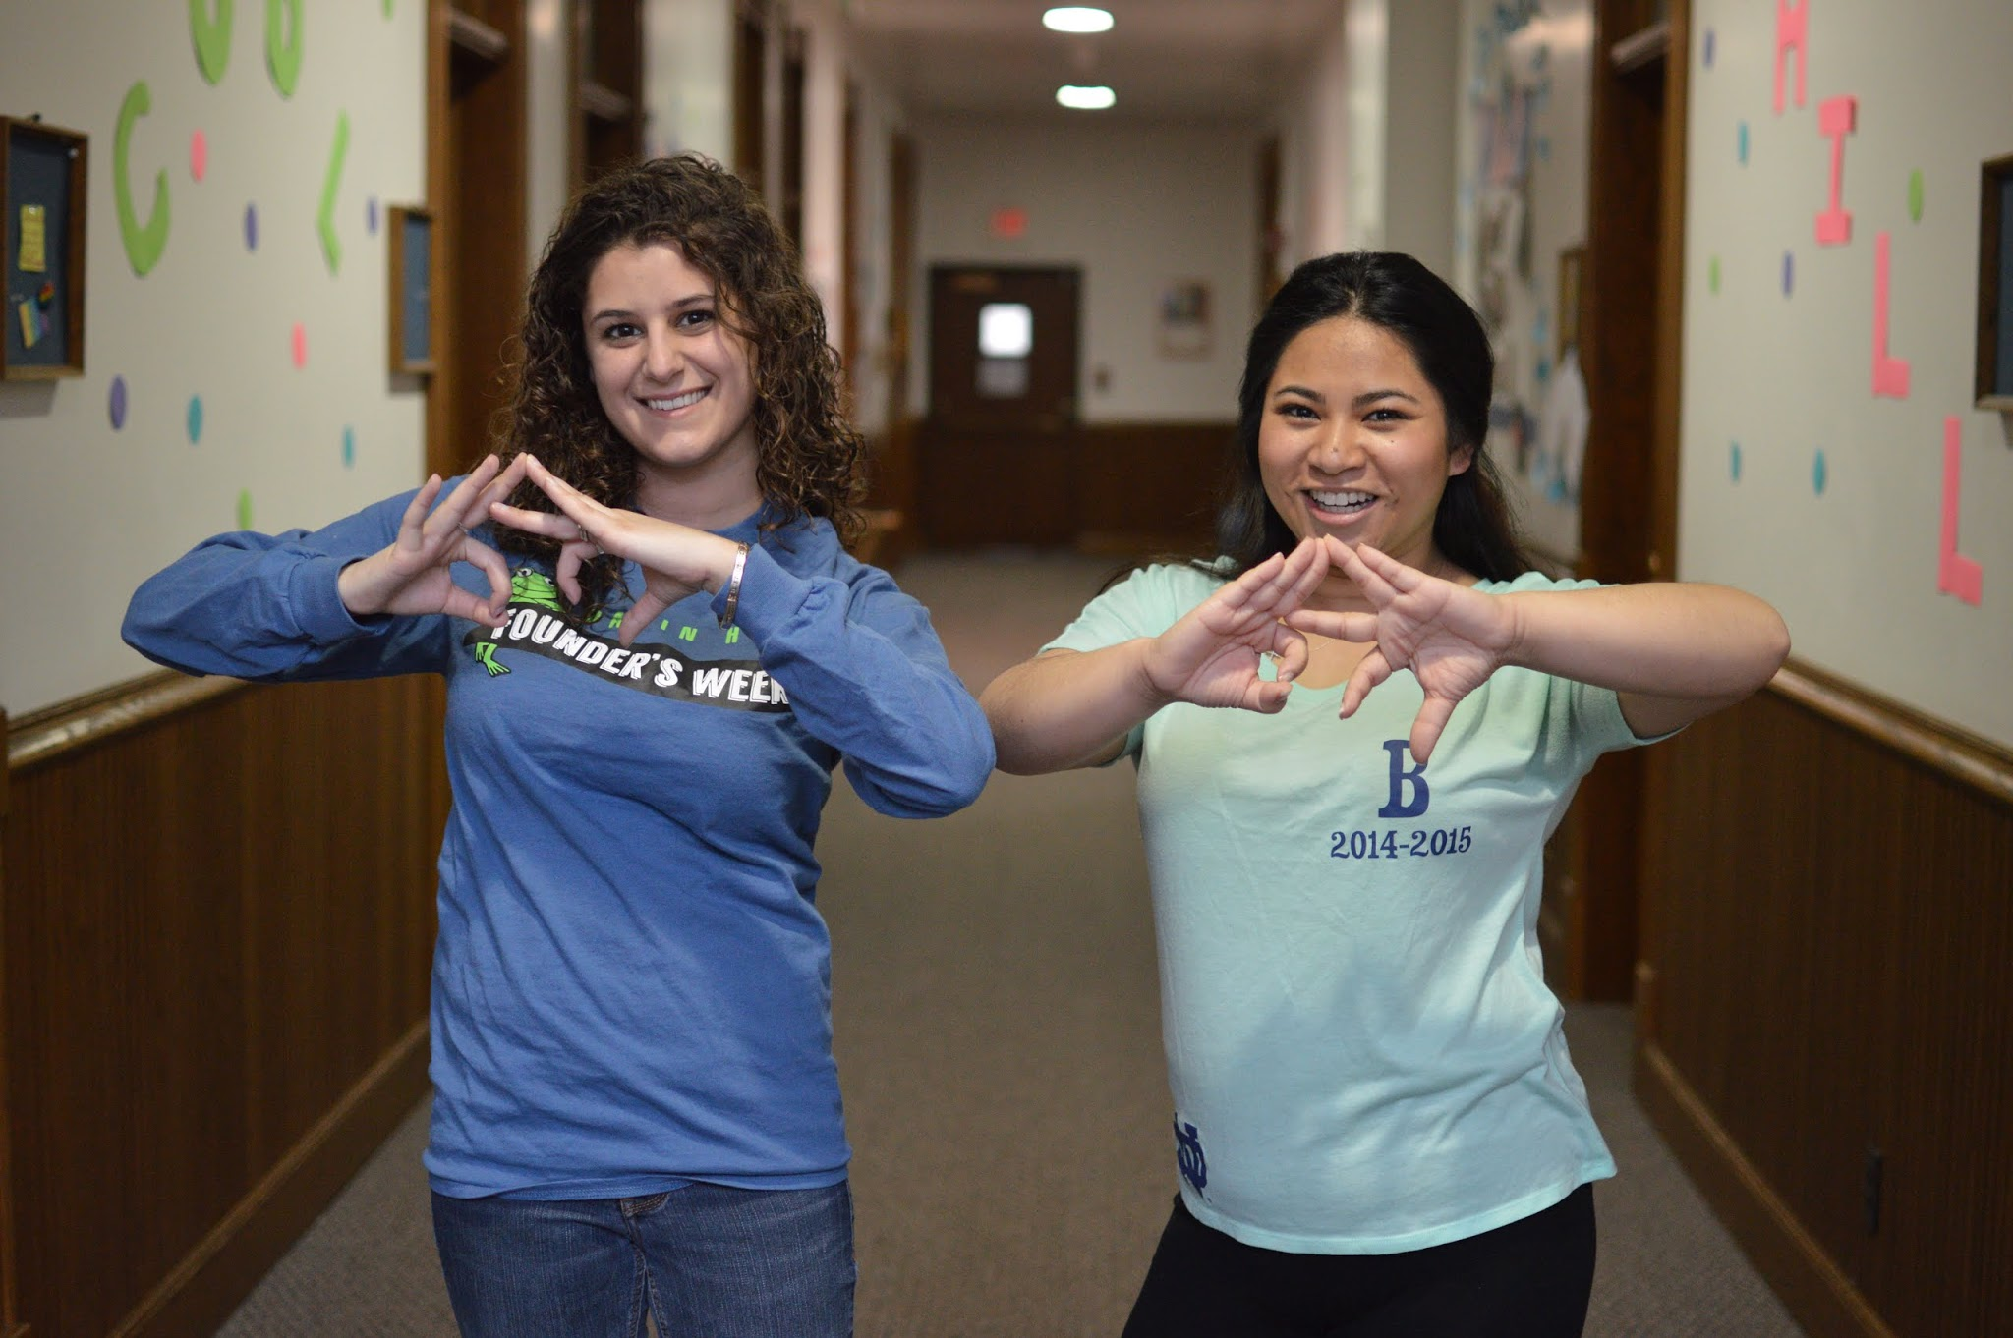 (DSC_1655)

tag Angela Massoud and Julia Le

*TWITTER:*

12pm

Passion. Unity. Identity. #RR2015

1 PM

Check out our platform at nd.edu/~brickett #RR2015

 (DSC_1837)

3PM

We look forward to meeting each of you this week to share our vision for Notre Dame with you! Look for us around campus! #RR2015

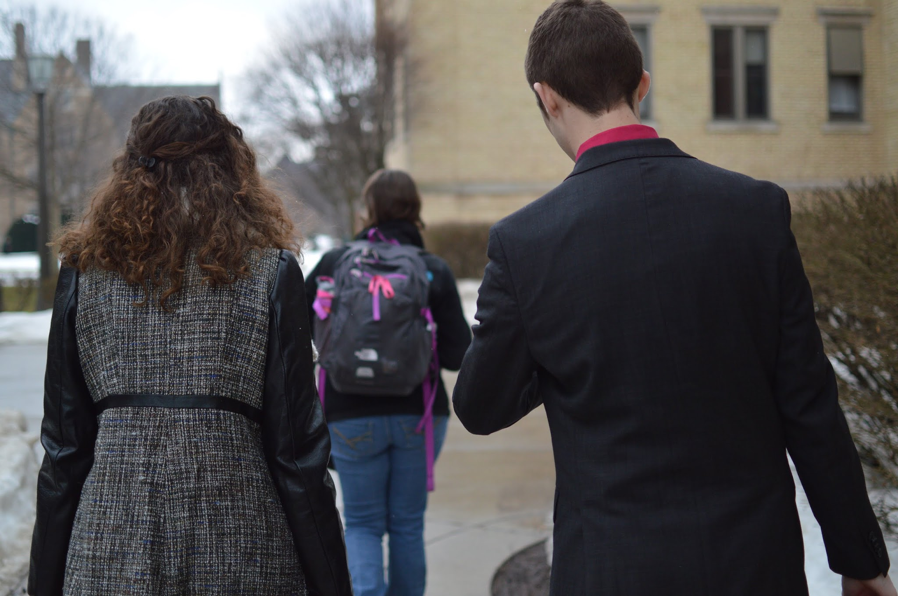 (DSC_1545)

5 PM

Visit us on Facebook!!! www.facebook.com/RickettsRuelas2015 #RR2015

5:30PM

Hey Stanford! Bryan is headed to your dorm to meet your residents! Looking forward to discussing the platform with you! #RR2015

6PM

Hey @BP_Babes! Be on the lookout for Nidia! She’s there now to answer questions and share insights! #RR2015

9:30PM

Hey @phriendlyphox! Nidia is on her way to share the platform with all of you! Can’t wait to meet all the Phoxes! #RR2015

*INSTAGRAM:*

12 PM

Bryan Ricketts & Nidia Ruelas are proud to announce their candidacy for Student Body President and Vice President. Visit facebook.com/RickettsRuelas2015 for more information!

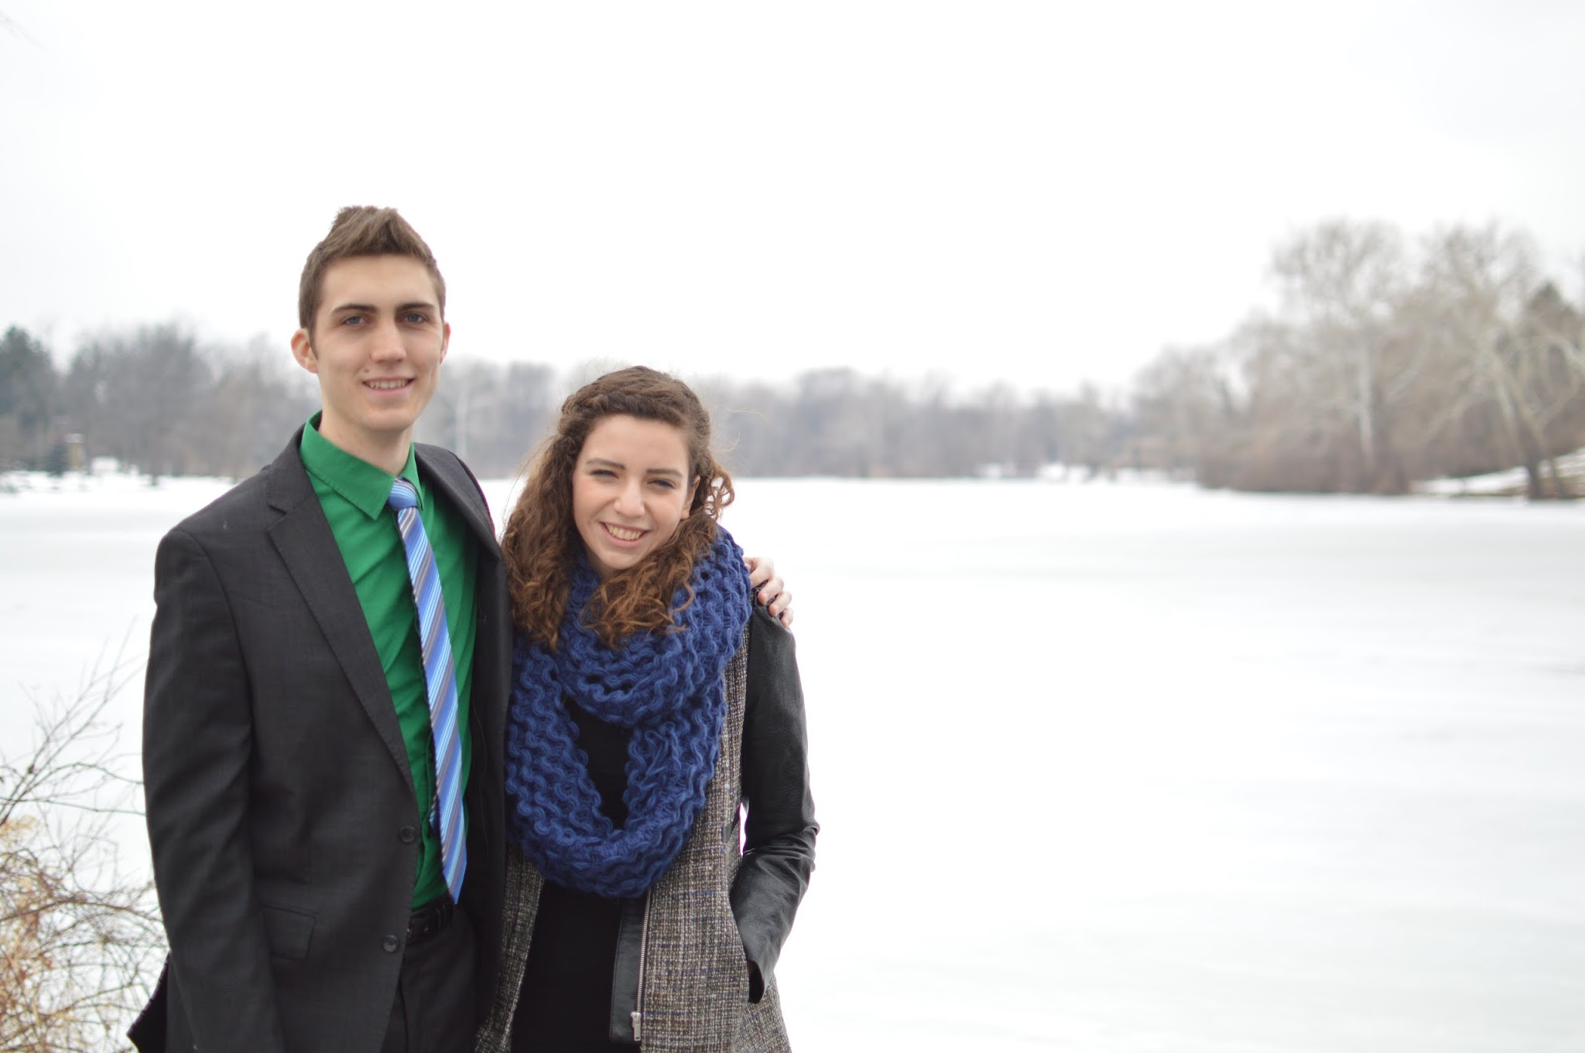 (DSC_1691)

5 PM

We’ve got your back! Learn more about our vision for student government at facebook.com/RickettsRuelas2015

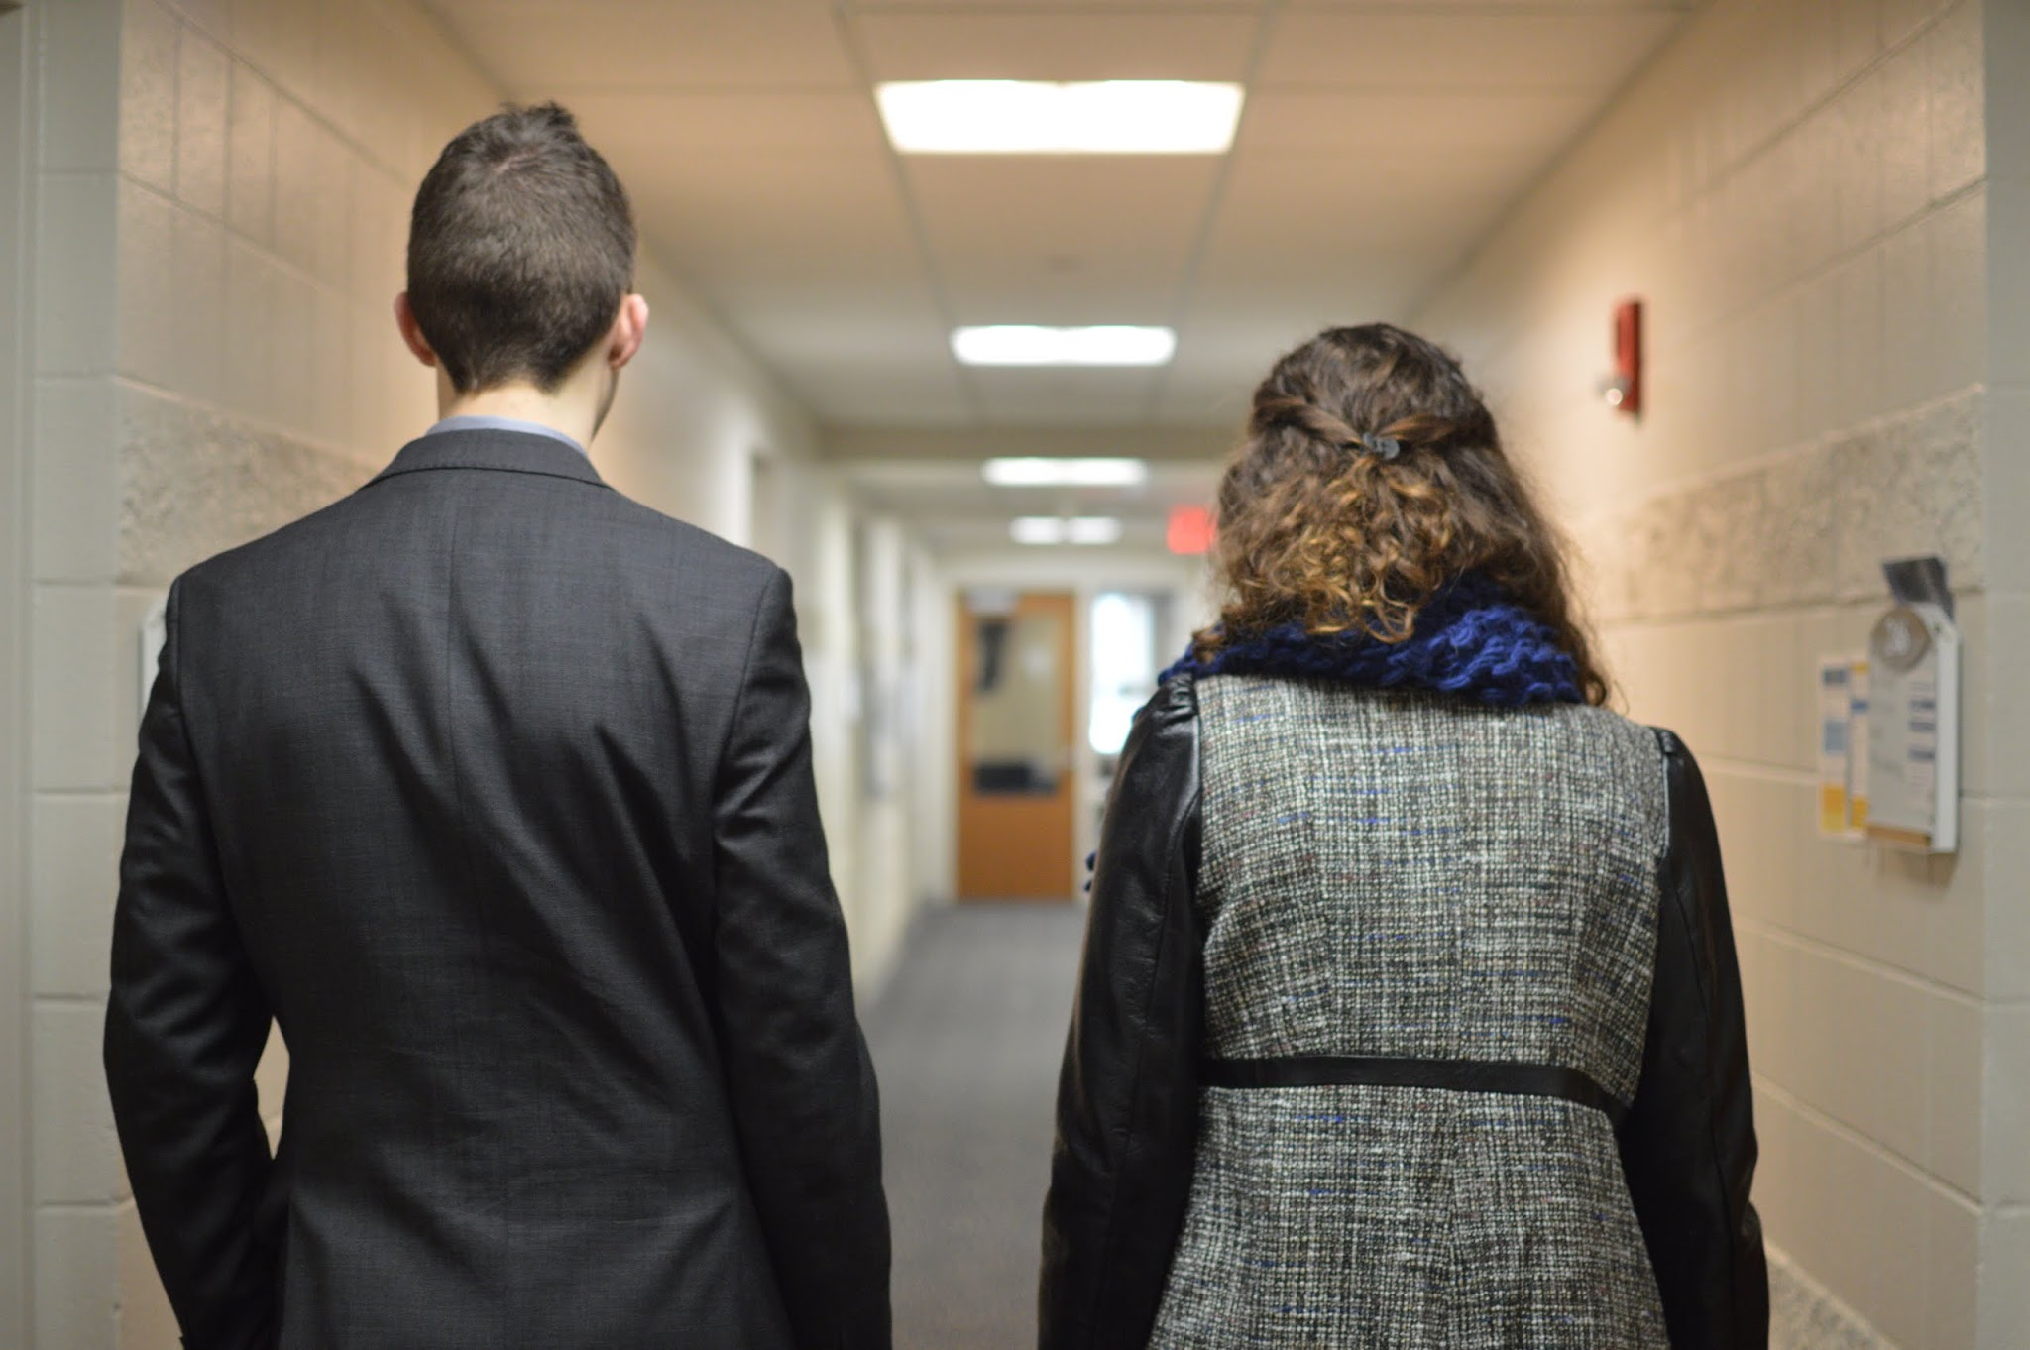 (DSC_1446)

**Day 2 (Wednesday):**

*FACEBOOK:*

9:30AM

Our #WCW is Nidia Ruelas! We love our scarf loving, French speaking VP! Check out this picture of her in France! #RickettsRuelas2015

(NidiaChair)

10 AM

We feel as done with DARTing frustration as you do! Simplifying the process, helping you find the classes you’re looking for, and giving you input in designing your system are all part of our platform. #RickettsRuelas2015

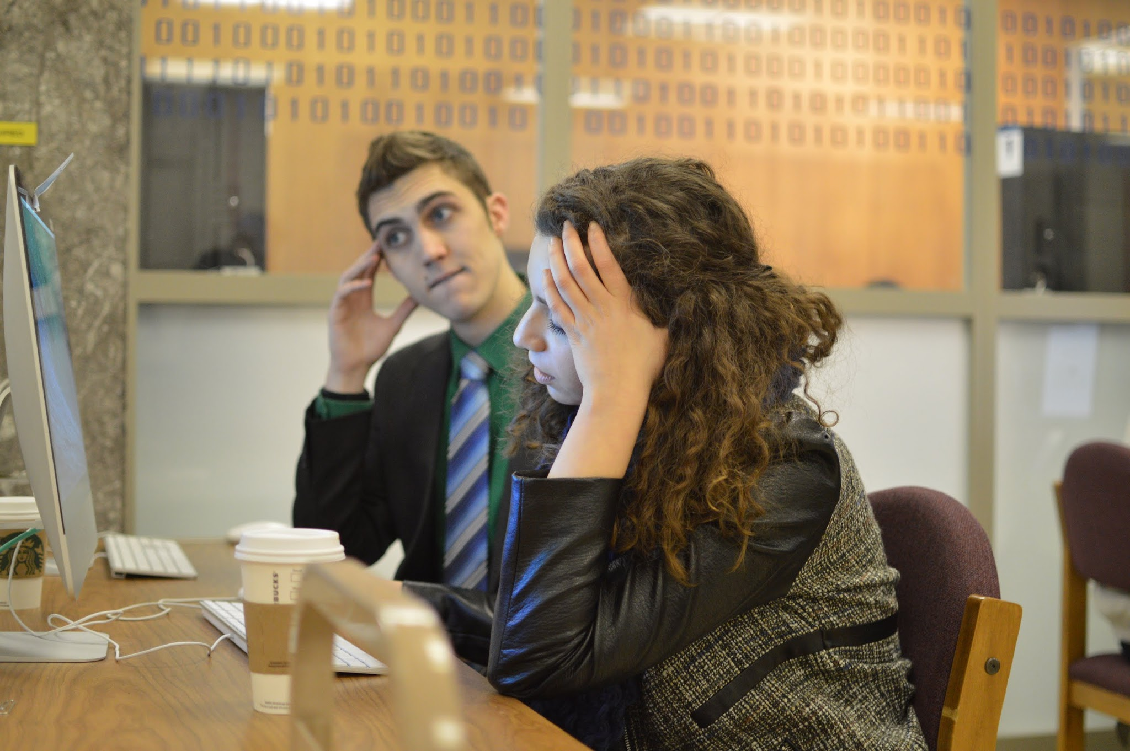 (DSC_1835)

12:30 PM

Ever feel like you're losing money each week when you can't use all your meal swipes? So do we! Enabling students to use multiple meal swipes during each meal period will allow us to take full advantage of our meal plans! #RickettsRuelas2015

5:00 PM

StudGov is an open dooooooor #RickettsRuelas2015

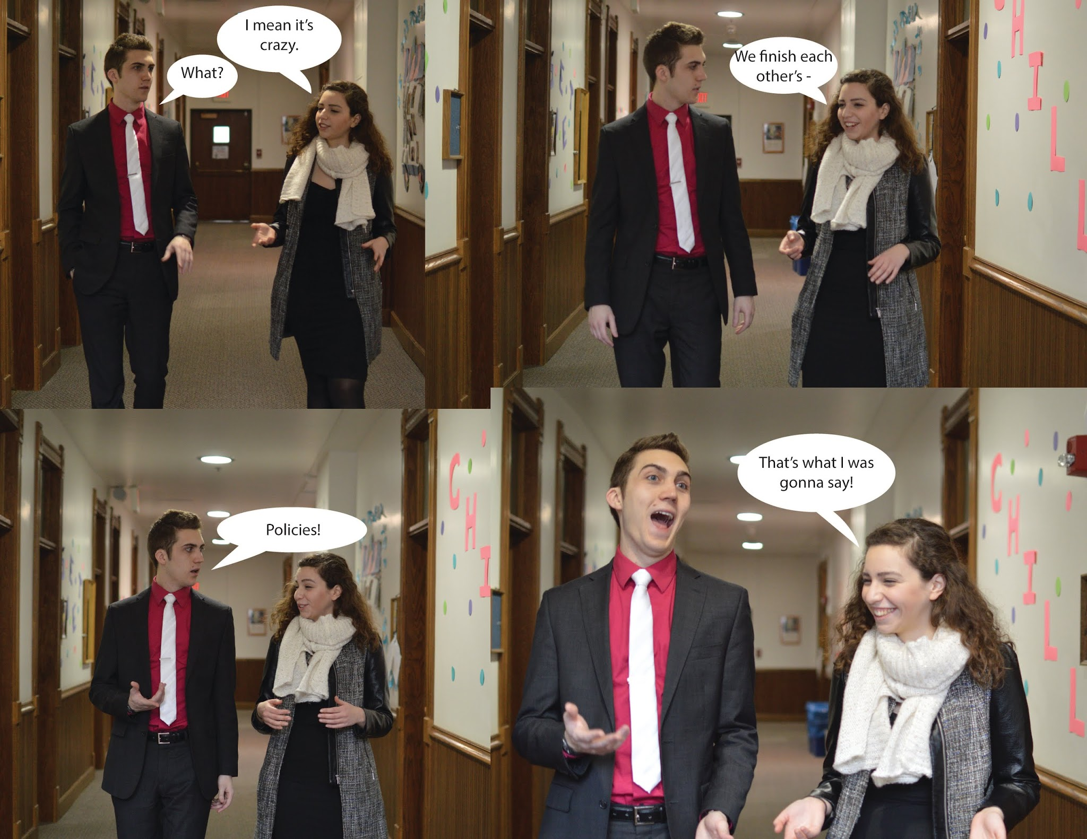 (Love is an open door)

*TWITTER:*

11AM

Our #WCW is Nidia! Look for her around campus today! #RR2015

(NidiaChair)

3PM

Quad Markets were a success this year! Let’s keep them going #RR2015

5:30 PM

@KeoughHall is the next stop on the campaign trail! Come meet presidential candidate Bryan Ricketts. #RR2015

6PM

@Lewis_Chicks, Nidia is in the building! Talk to her about our plans for Student Government! #RR2015

8:45 PM

@ONeillMobsters We're coming your way! Can't wait to chat about our vision for student government. #RR2015

9PM

@Lewis_Chicks, Nidia has left the building! @McGlinnHall, you’re next on the trail! Keep an eye out for Nidia in your dorm tonight! #RR2015

*INSTAGRAM:*

Our #WCW is Nidia Ruelas! Learn more about our VP candidate by visiting facebook.com/RickettsRuelas2015

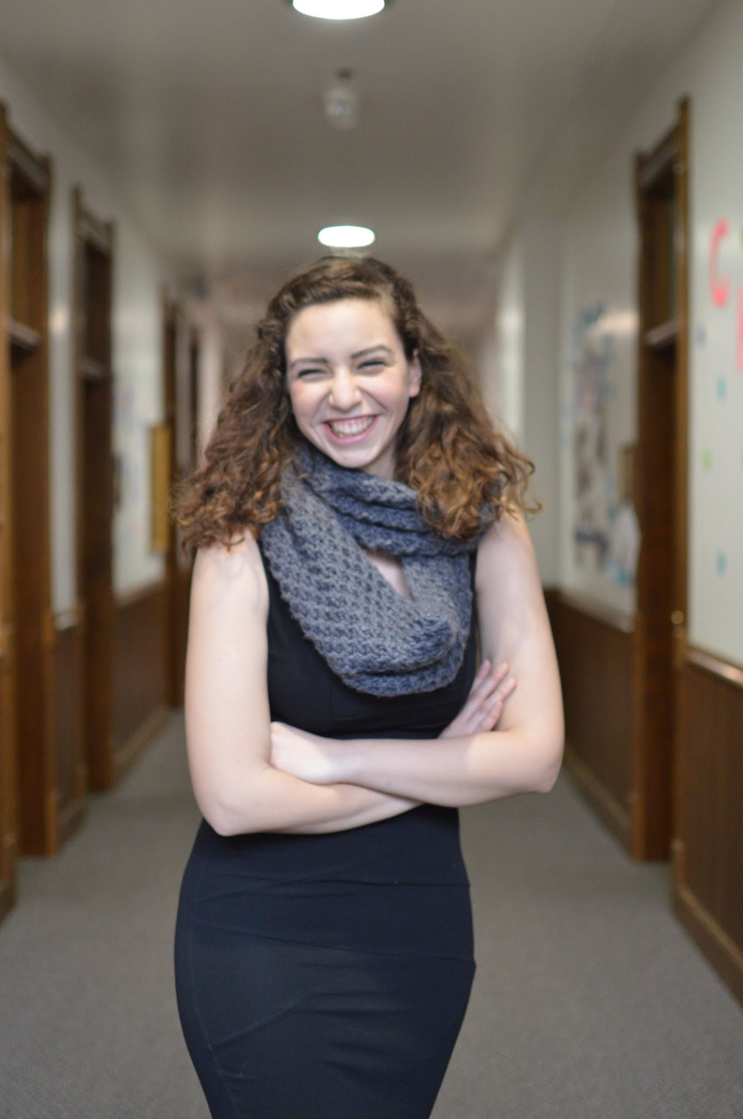(DSC_1649)

Not quite an audience with the pope, but still a fun visit to Campus Ministry!

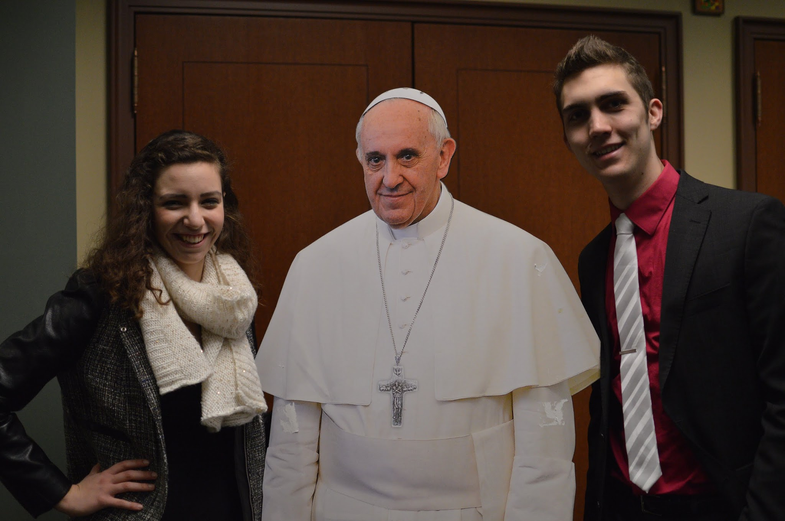 (DSC_1526)

**Day 3 (Thursday):**

*FACEBOOK:*

9:30 AM

Do you like throwbacks? So do we! Look at how cute Bryan and Nidia were back in the day #tbt #weflawless #RickettsRuelas2015

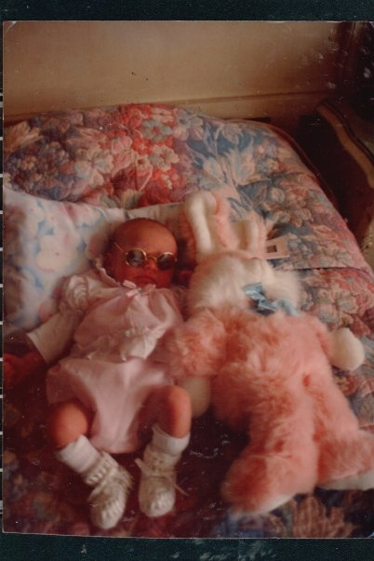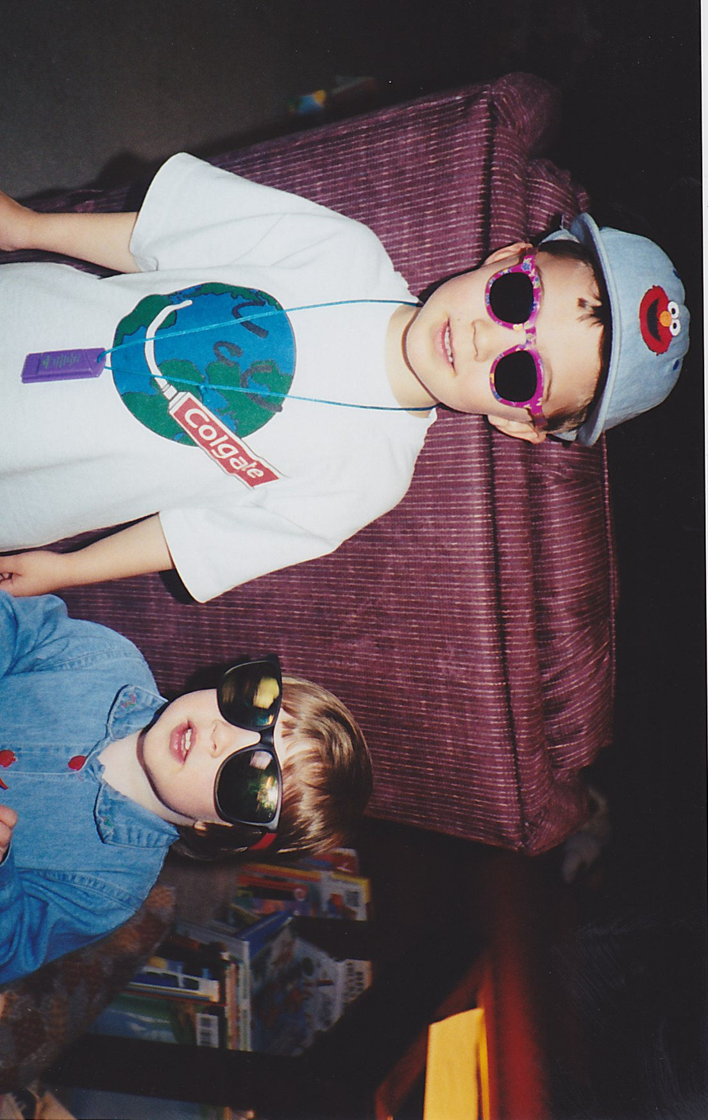

Share your #tbt of a great memory with Bryan or Nidia (or both!) with us today on Facebook, Twitter or Instagram! Remember to tag us!

12:30 PM

We seek to advocate for safety, confidentiality, and respect in all conversations and initiatives surrounding diversity and inclusion. We plan on doing this by supporting the implementation of the 21 Diversity Recommendations as outlined by Student Affairs. Check them out at <http://sadiversityrecos.nd.edu/> #RickettsRuelas2015

5:00PM

Ever had an idea or a problem and not known where to turn? We want to bring students and administrators together in an online forum to open direct lines of communication between your passions and the people who can make them realities. #RickettsRuelas2015

12 AM

It's midnight! Are you in line to get a Quarter Dog?!

We love this ND tradition and will keep it going strong with continued subsidization that will keep Quarter Dogs costing just a quarter! #RickettsRuelas2015

*TWITTER:*

11AM

#tbt to when Nidia first decided to run for Student Vice President. #RR2015

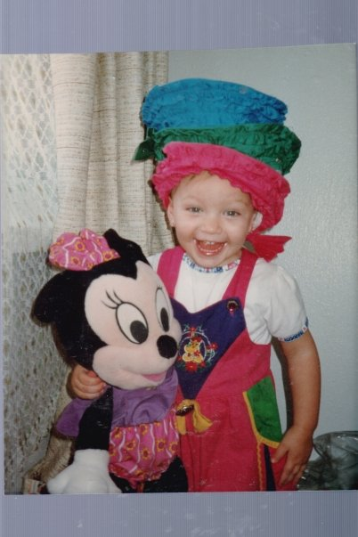

#tbt to when Bryan made his decision to run! #RR2015

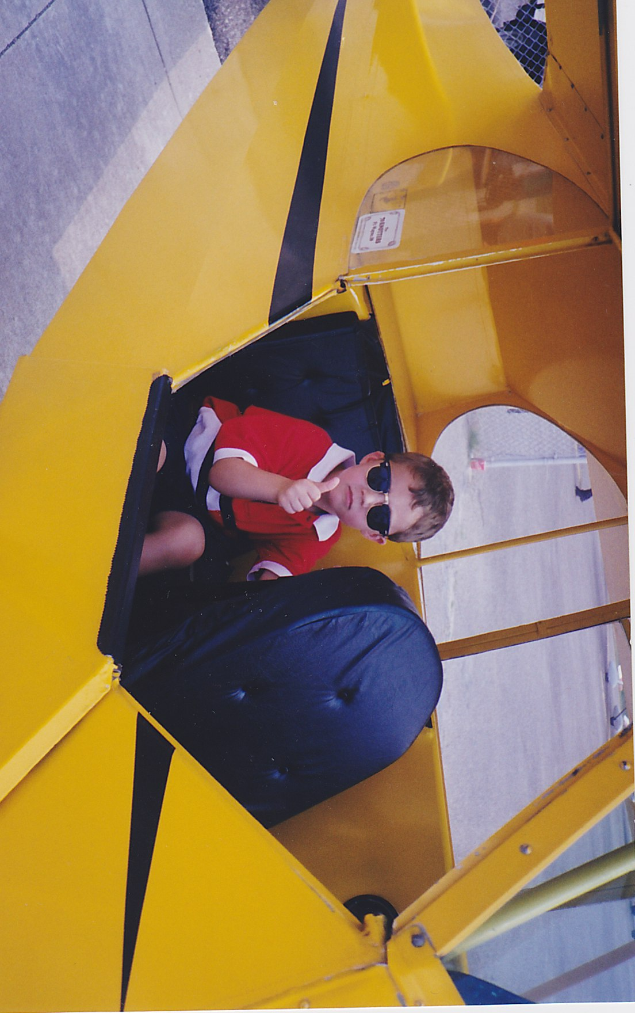

12 PM

Come have lunch with us and learn more about our vision for ND! We will be at SDH from 12:30-1:45! Hope to see you there! #RR2015

3 PM

Let's not choose between helping a friend and staying out of trouble. We plan to implement a medical amnesty policy to protect our students.

6 PM

@DillonHallND want a chance to talk platform? Bryan Ricketts is headed your way for the next few hours! #RR2015

6PM

@HowardHall Ducks, Nidia is waddling over to talk to you all about our plans for Student Government! #RR2015

8:15PM

@WalshWILDwoman, have any questions about our platform? Ask Nidia! She is excited to come visit you next! #RR2015

9PM

St. Edwards Hall is closing out the third day of campaigning! Looking forward to meeting all of the Gentlemen! #RR2015

12PM

After a long day talking to all of you, we’re ready for some Quarter Dogs! #RR2015

*INSTAGRAM:*

#tbt to when Bryan decided to run for Student Body President.

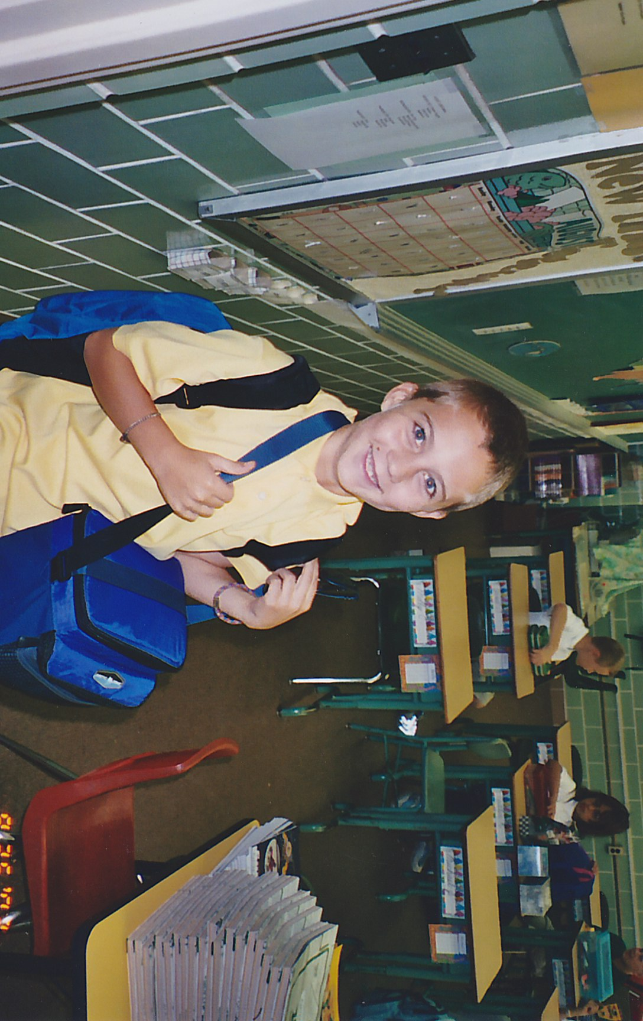

#tbt to when Nidia decided to run for Student Body Vice President.

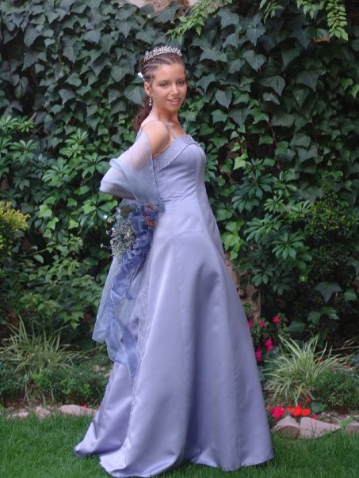

We’ve been hard at work this week, so it’s time for a coffee break! Find out where we’re going next by following us on Twitter @RickettsRuelas15

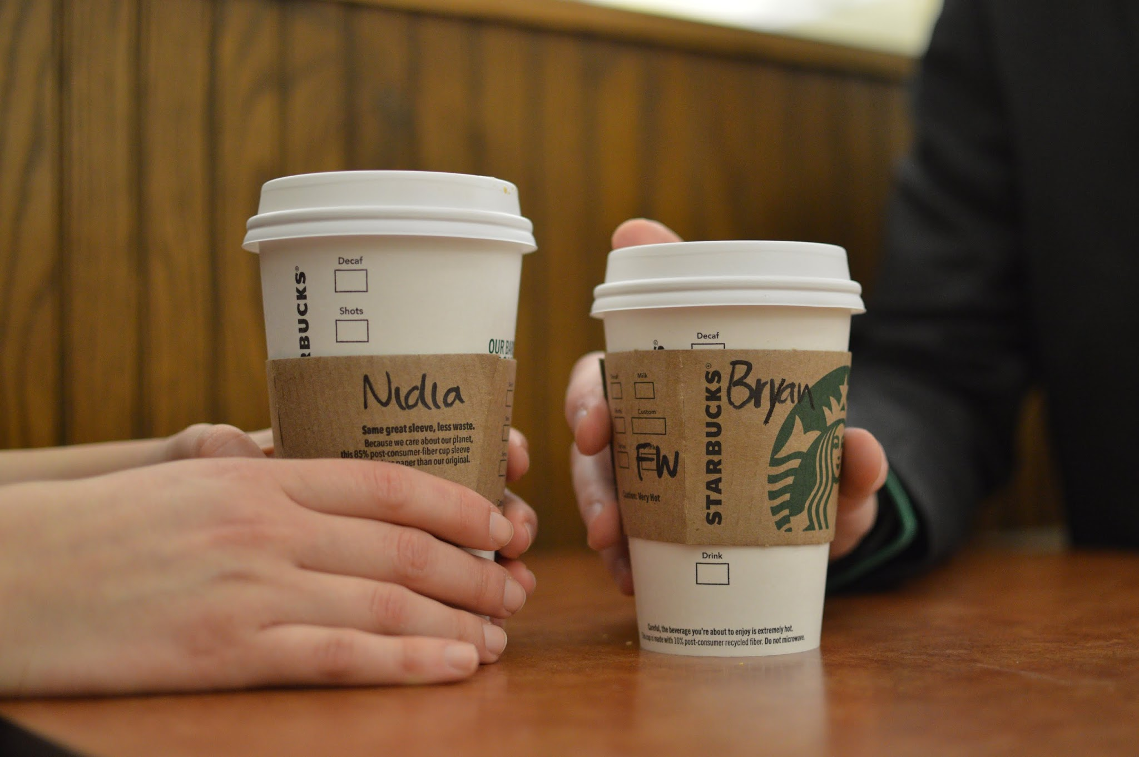

**Day 4 (Friday):**

*FACEBOOK:*

12:00 PM

I be on my Scarf&Tie #the2015experience #RickettsRuelas2015

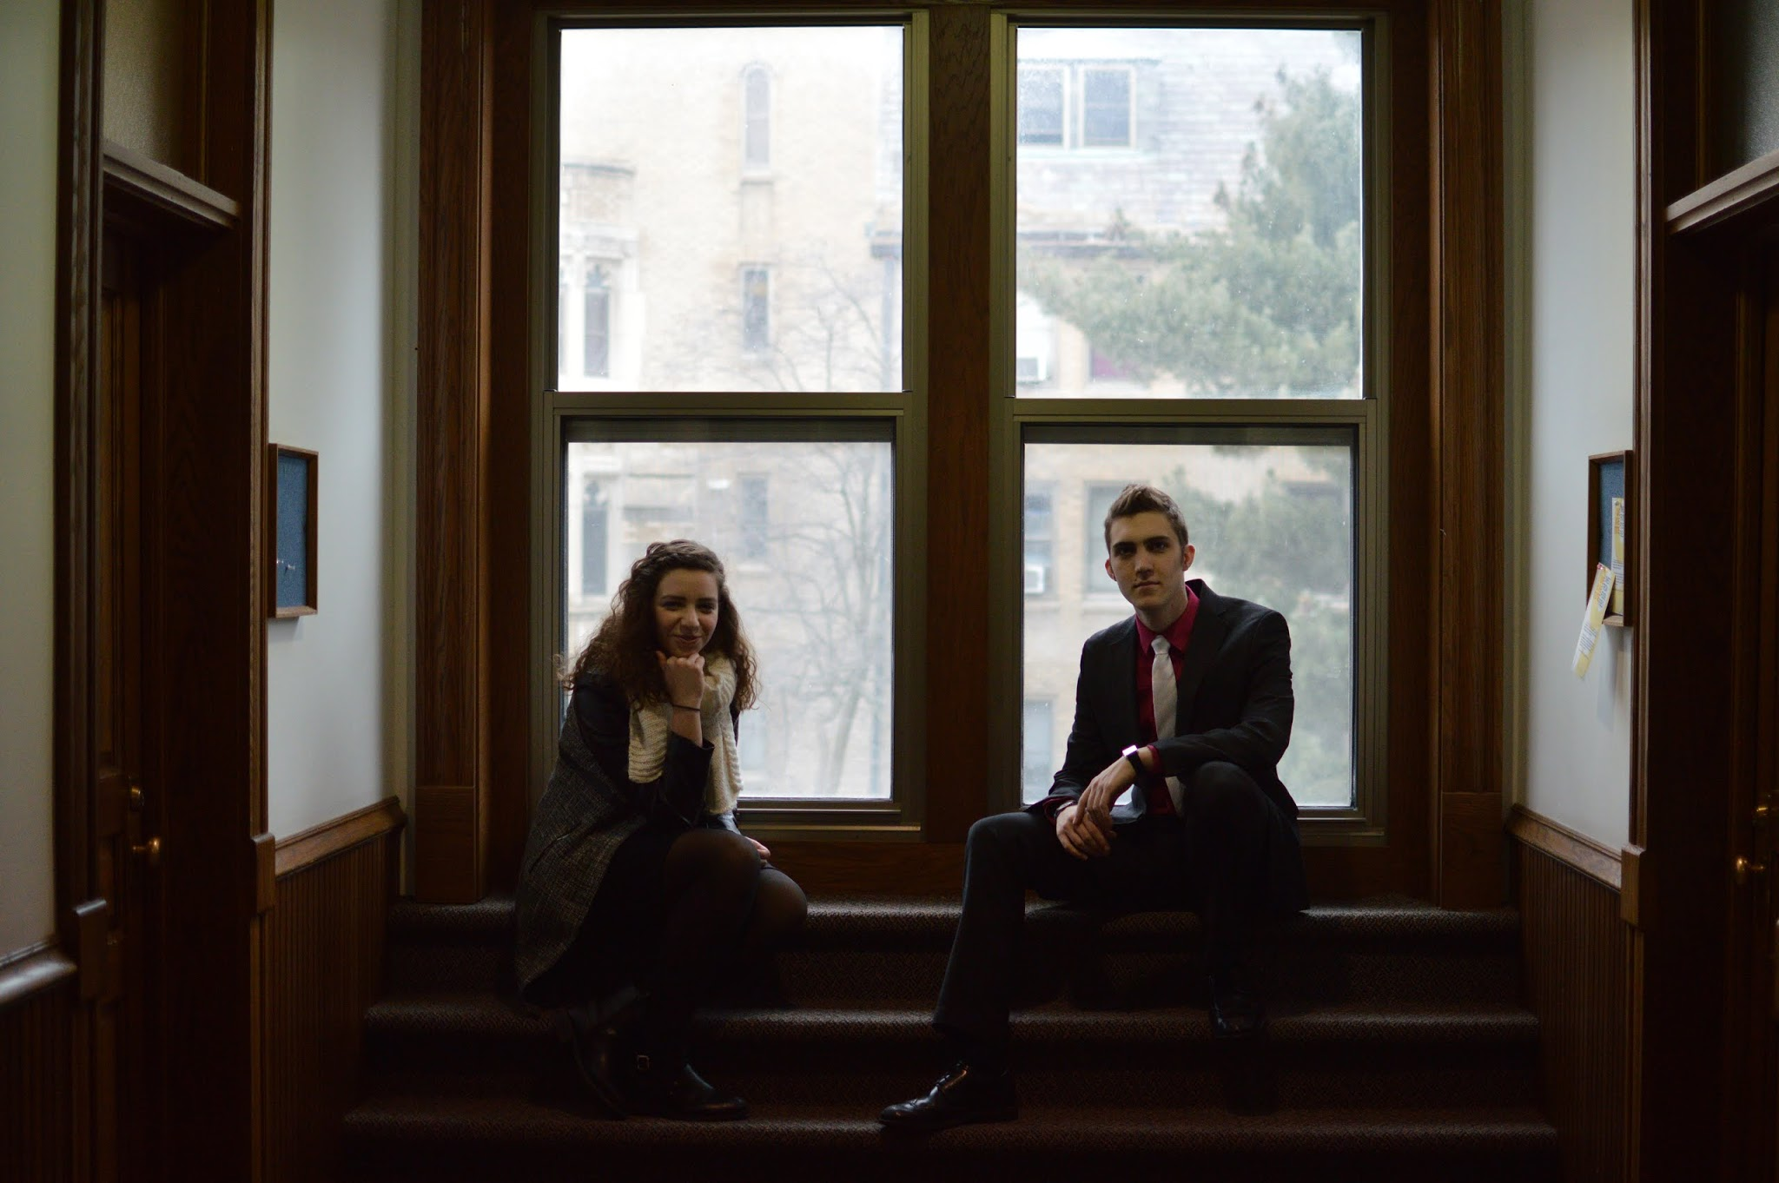 (DSC_1556)

2:00 PM

Did you know that a new O’SNAP app is coming out? Safety and communication should always be a top priority -- let’s work to make sure this is the case. #RickettsRuelas2015

5:30 PM

Look who we ran into! Alex Coccia, former Student Body President, supports Bryan and Nidia! #votethebeard #RickettsRuelas2015

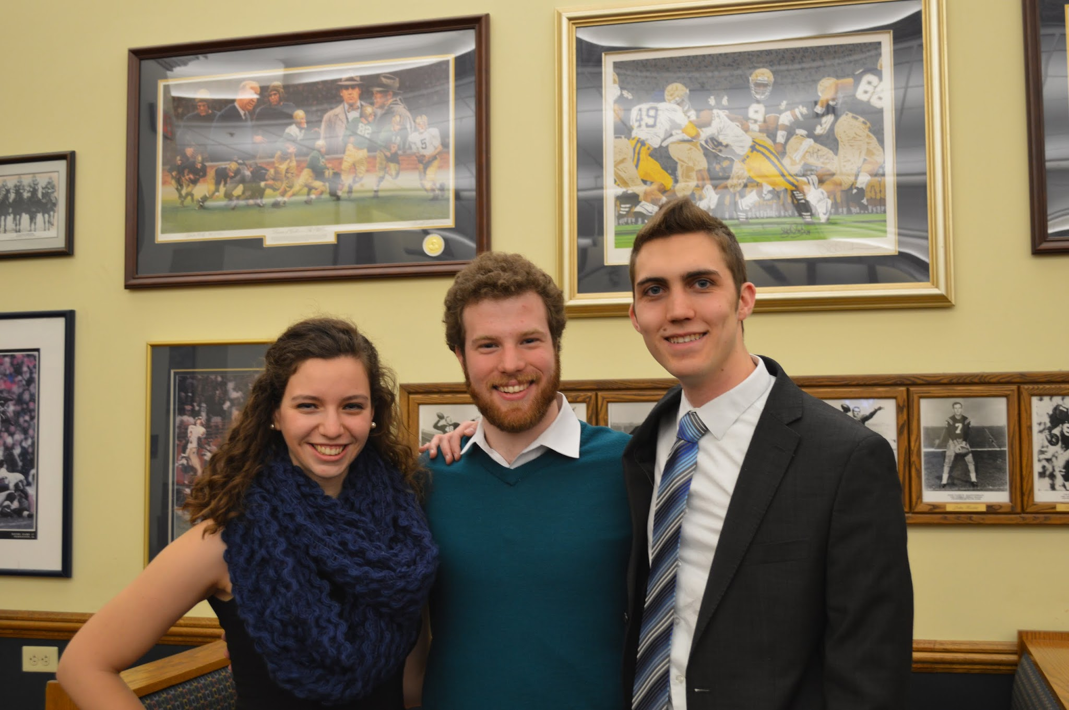

*TWITTER:*

11AM

Head on over to NDH to meet Bryan and Nidia for lunch! We’d love to chat with you about our platform! #RR2015

3PM

I be on my scarf and tie… Bryan and Nidia love theirs! Even @jtimberlake approves! #the2015experience #RR2015

 (DSC_1556)

5:30 PM

Time to visit @morrisseymanor to let the manorites know what Ricketts Ruelas 2015 is all about! #RR2015

5:30PM

@BadinBullfrogs, Nidia is hopping over to visit her favorite frogs! Stick around to ask her about Ricketts Ruelas 2015! #RR2015

*INSTAGRAM:*

I be on my scarf and tie… Bryan and Nidia love theirs! #the2015experience #RR2015

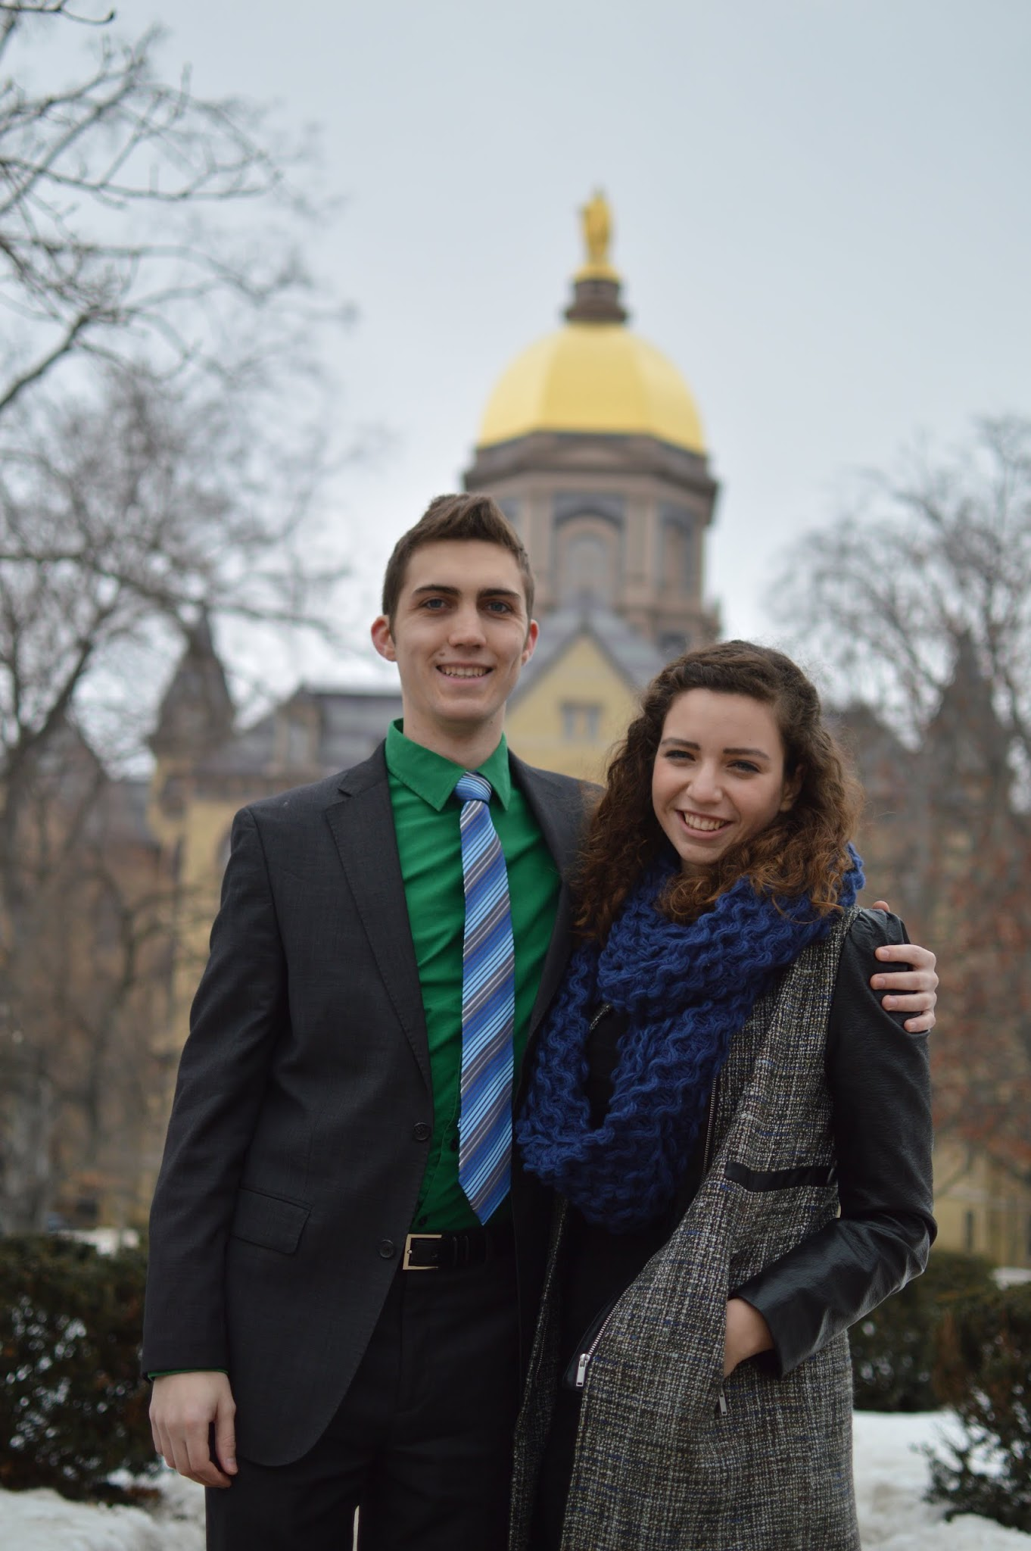 (DSC_1768)

**Day 5 (Saturday):**

*FACEBOOK:*

10:30AM

Take a #Selfie with the #RickettsRuelas2015 team today! We plan to implement a responsive and engaging social media strategy during our term, reaching the student body in ways that are relevant and accessible.

Don’t forget to tag us in your #Selfie!

12:00 PM

We've had so much fun talking with you these last few days. Let's keep it going! Tell us about your #Passions! #RickettsRuelas2015

3:00 PM

Sexual Assault is an issue that affects all of us, which means we all have to take a stand. That’s why we support the current It’s On Us campaign, and will continue to promote resources and spread awareness through our entire term.

5:00 PM

Need funding? Find out about all the cool opportunities and internships across campus in a centralized guide and make sure you are all covered for your adventures abroad and your professional future. #RickettsRuelas2015

*TWITTER:*

12PM

We want to hear about your passions as we continue to share ours with you! #Passion #RR2015

1 PM

Time to share our #Passion for student government with Alumni Hall! #RR2015

1PM

Nidia can’t wait to share her #Passion with @Farley_Hall! Be on the lookout for her this afternoon! #RR2015

2:30PM

@thenaugh, Nidia is excited to meet the #Chaos. While anarchy didn’t make the platform, she is still excited to share her #Passion with you!

3:30 PM

Hey Otters of @sorincollege, Bryan is headed your way! Let's chat about our vision for a dynamic student government! #RR2015

4:30 PM

@PWweasels, say hi to Nidia before heading off to dinner! She will be walking around for the next two hours! #RR2015

5:30 PM

Doing homework in Lafun? Stop by Subway to chat with Bryan and Nidia about their plans for Student Government! Hope to see you there! #RR2015

6:30 PM

Ready to roam the halls of @KnottHallGov! Looking forward to meeting your residents! #RR2015

7 PM

Looking for a movie to watch tonight? We hope to install a Redbox on campus and allow students easy access to all the hottest films. #RR2015

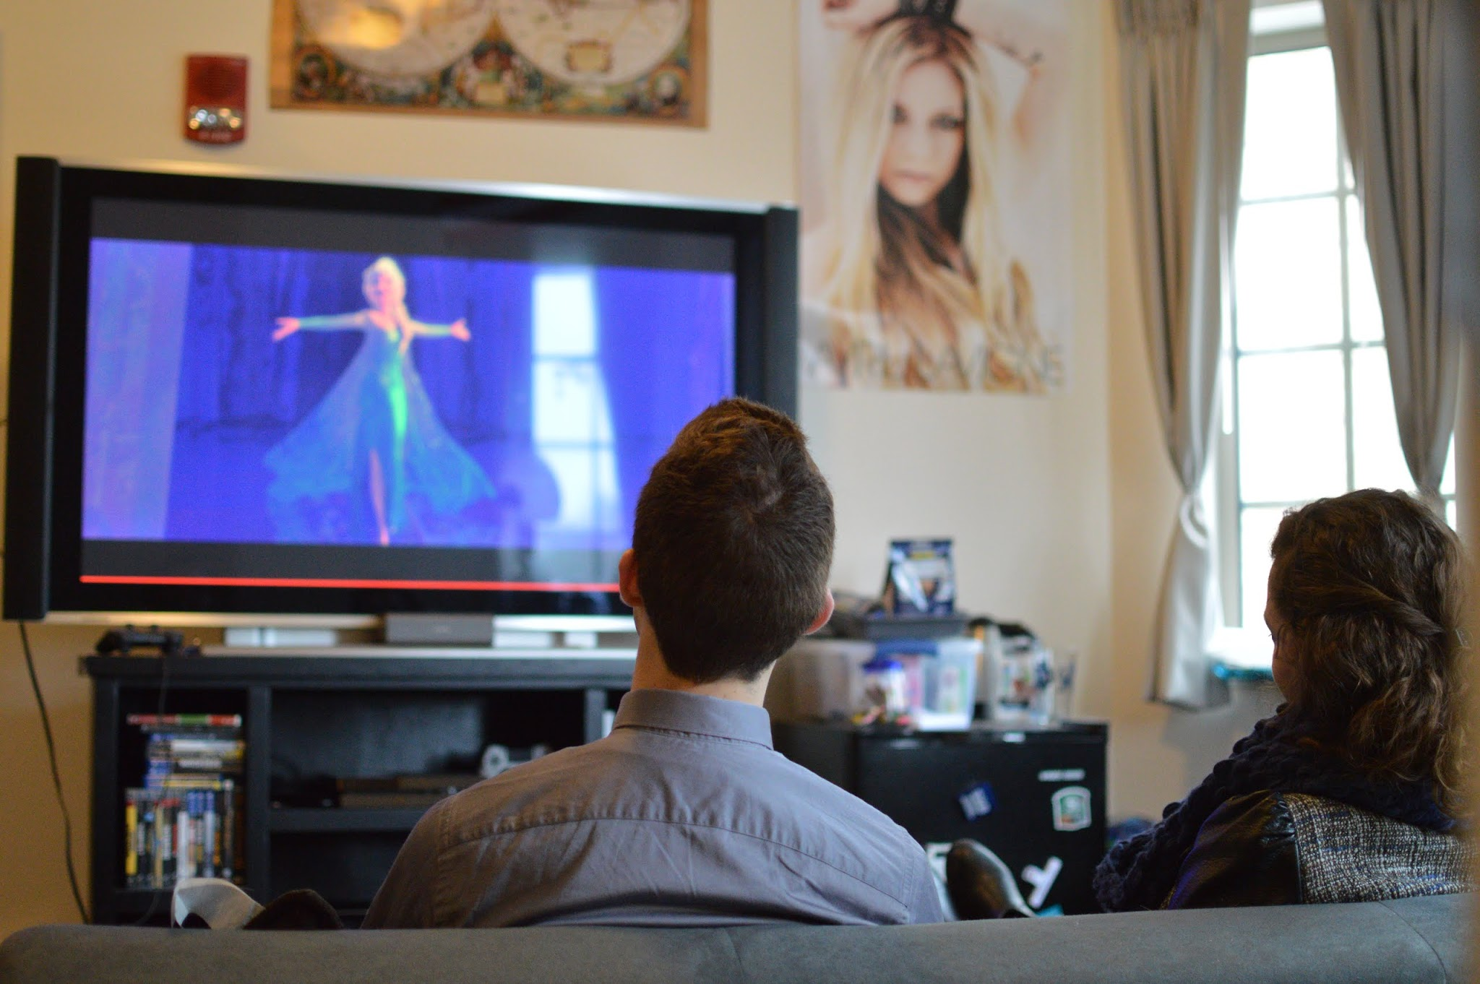(DSC_1436)

*INSTAGRAM:*

Everybody has their #Passion. Let us know what yours is!

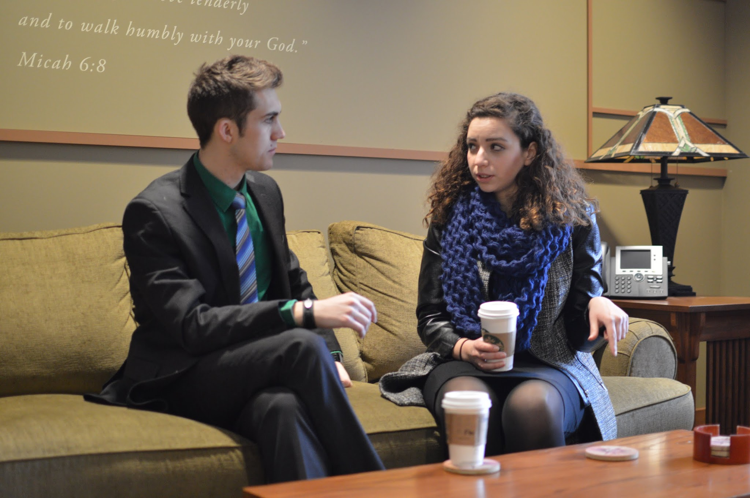 (DSC_1809)

Time for a homework break!

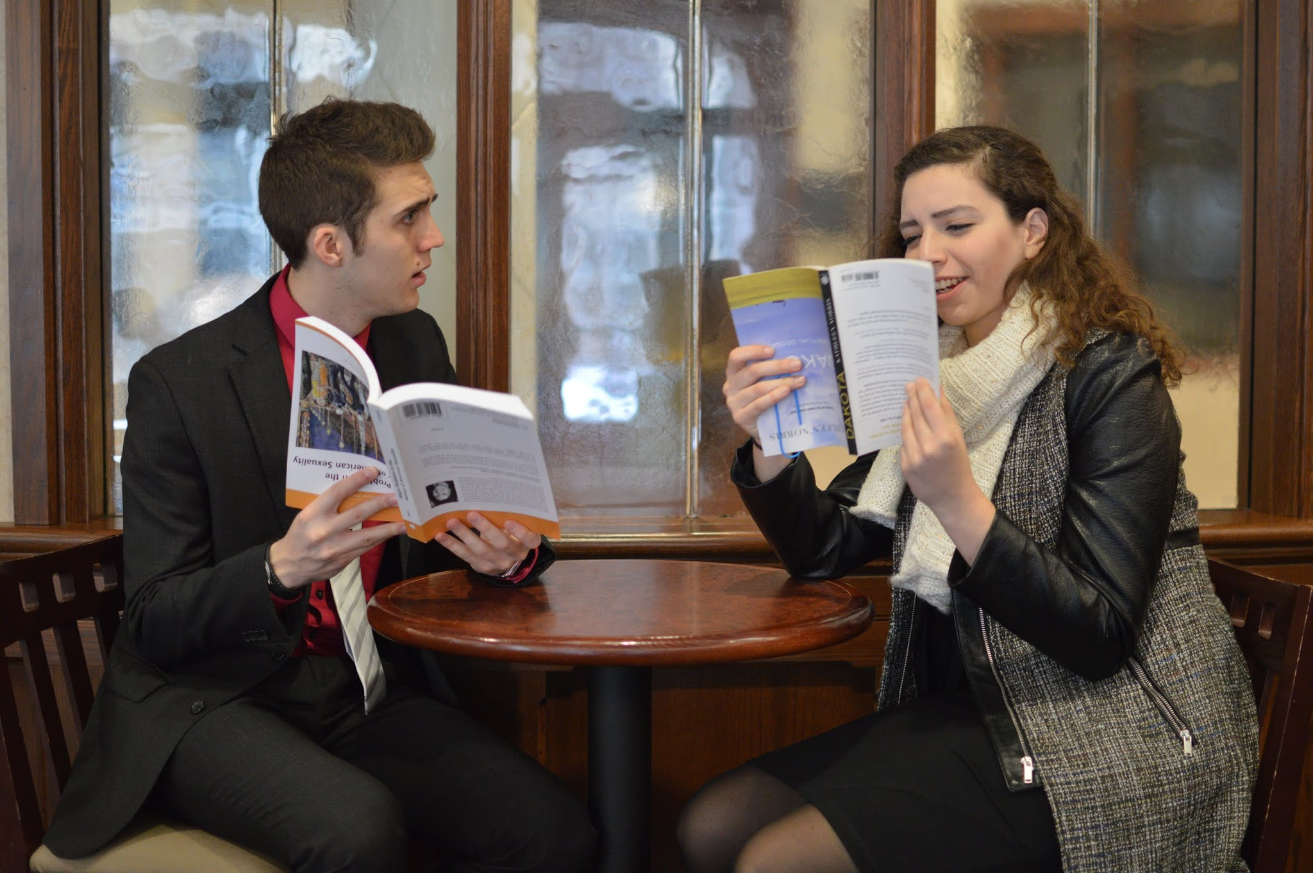 (DSC_1539)

**Day 6 (Sunday):**

*FACEBOOK:*

12:00 PM

We are ND. Let us know how you’re part of the Notre Dame family using #Unity! #RickettsRuelas2015

2:00 PM

Bring recognition and (semi)eternal glory to your clubs by showing us the awesome things you are all up to! #RickettsRuelas2015

4:00 PM

Let’s come together as students, administrators, and staff to make everyone feel welcome and at home from day one of Frosh-O. #RickettsRuelas2015

8:00 PM

Heading over to mass? So are we! Let’s all come together as a community to grow in faith and love. #RickettsRuelas2015

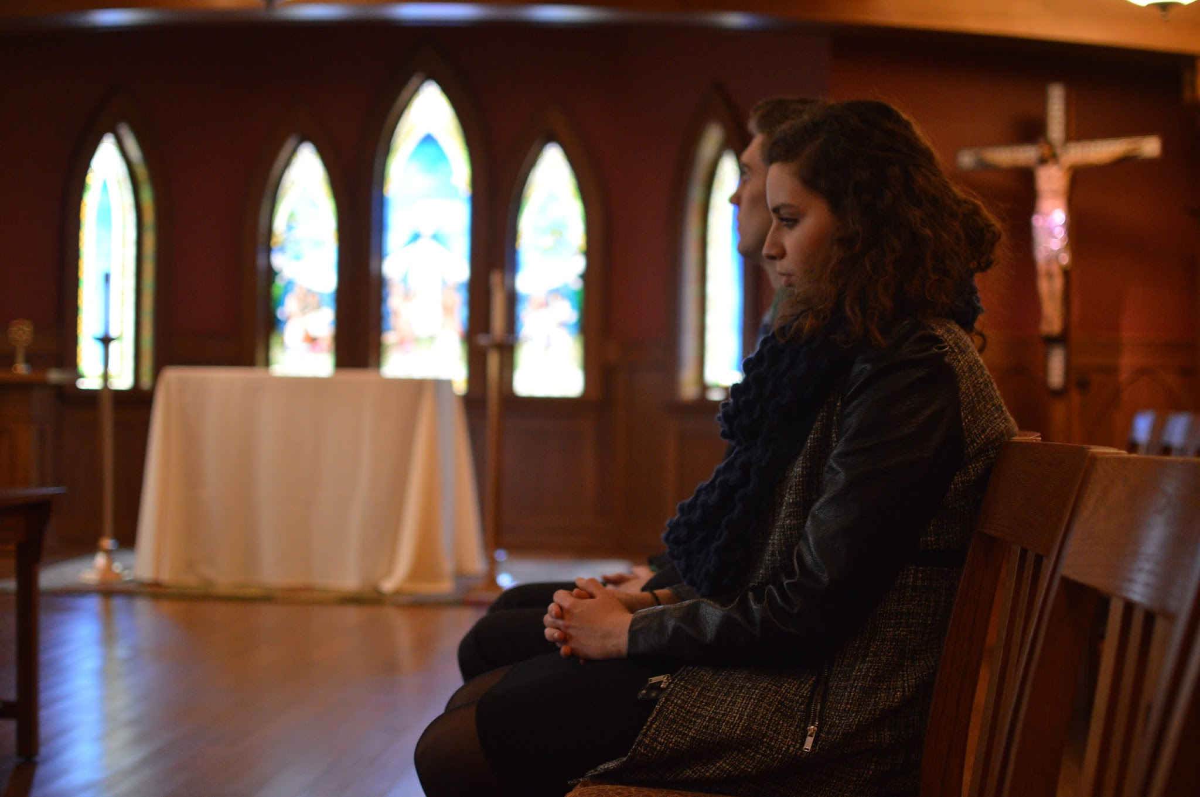 (DSC_1825)

*TWITTER:*

11AM

We are ND. Share your stories of #Unity with us! #RR2015

12 PM

Starting off our Sunday in Keenan Hall! It's an early morning with the Knights! #RR2015

12 PM

@LyonsHall, your very own Nidia will be walking around this morning sharing her vision for #Unity in Student Government! #RR2015

12:30 PM

Going to brunch? We hope to bring more healthy dining options to NDH and SDH. #RR2015

2 PM

Hey Wildcats! Nidia is coming to @RyanHallND to share our vision for #Unity! We’re All In This Together! You can Bet on It! #RR2015

3:30 PM

@ZahmHouseND, Bryan is visiting the House next! He hopes to share his vision for #Unity with all of the Zhambies! #RR2015

3:30 PM

@PEPyros, Nidia is coming over with some #hot topics to discuss with y’all! Look for her heating up your hallways! #RR2015

5 PM

All clubs and organizations make important contributions to ND, the community and the world. We want to collaborate and support all groups.

7 PM

@CarrollHall, Bryan is bringing the news about elections across the lakes to talk to you all about our platform! #RR2015

8:15 PM

Hey Ramblers, Bryan is excited to share our vision for #Unity with @SiegfriedHall tonight! #RR2015

9PM

Start your week off right with the most important meal of the day: Breakfast! Bryan and Nidia will be at SDH at 9am! #RR2015

*INSTAGRAM:*

On our day with the most dorm visits, we’d like to share some pics of our candidates back in their own dorms! Here’s Bryan in Duncan:

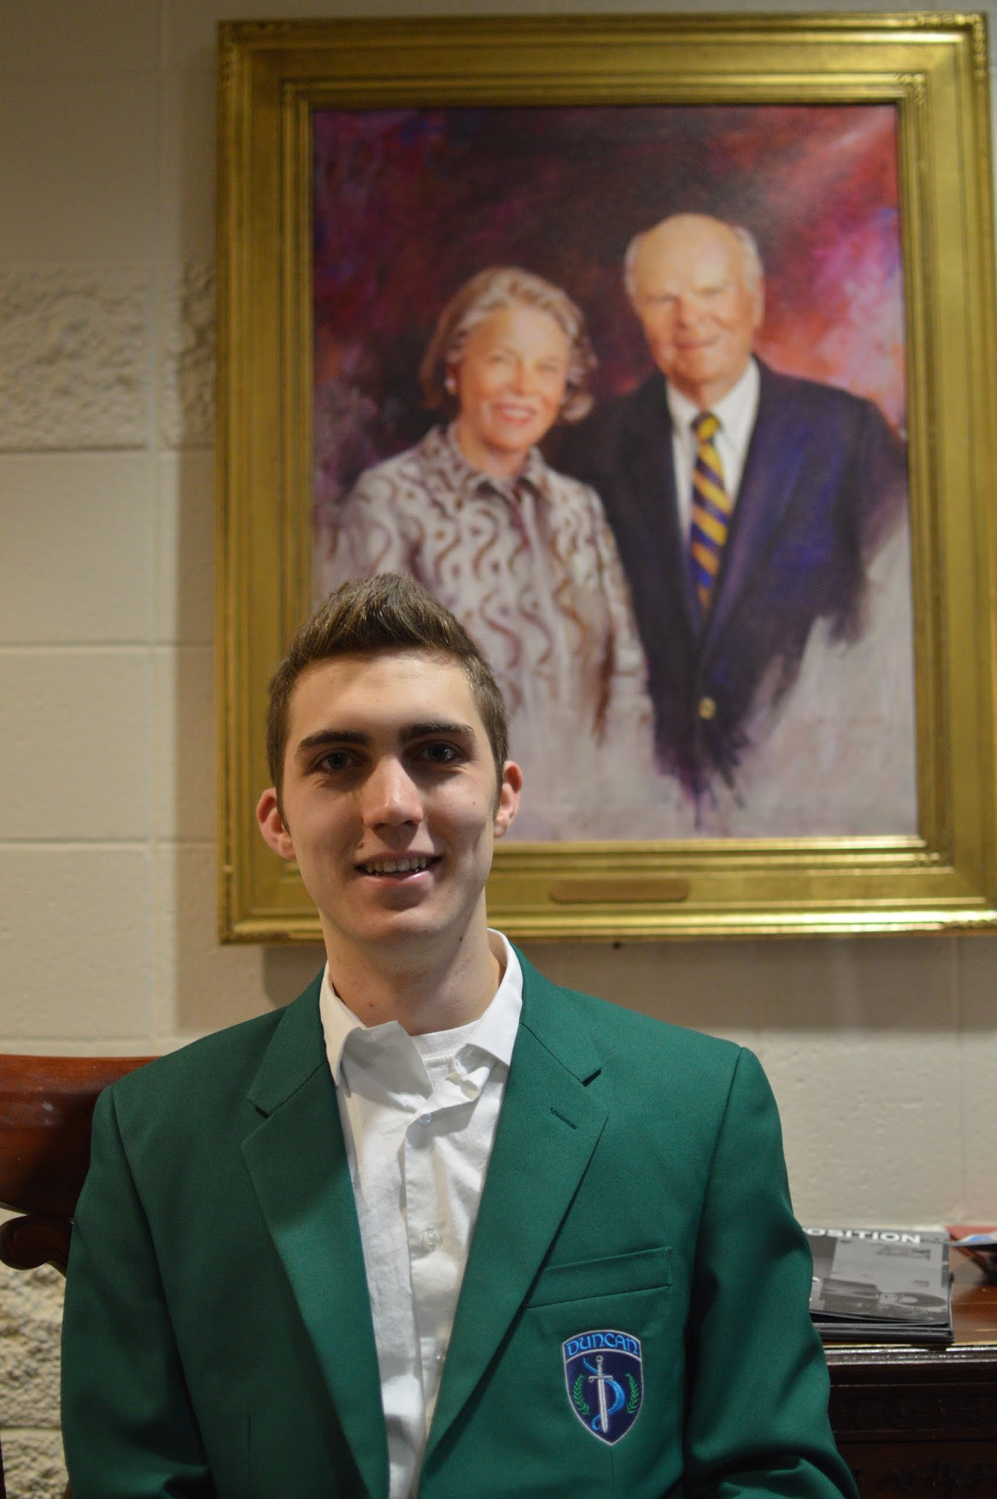 (DSC_1456)

And Nidia in Welsh Fam!

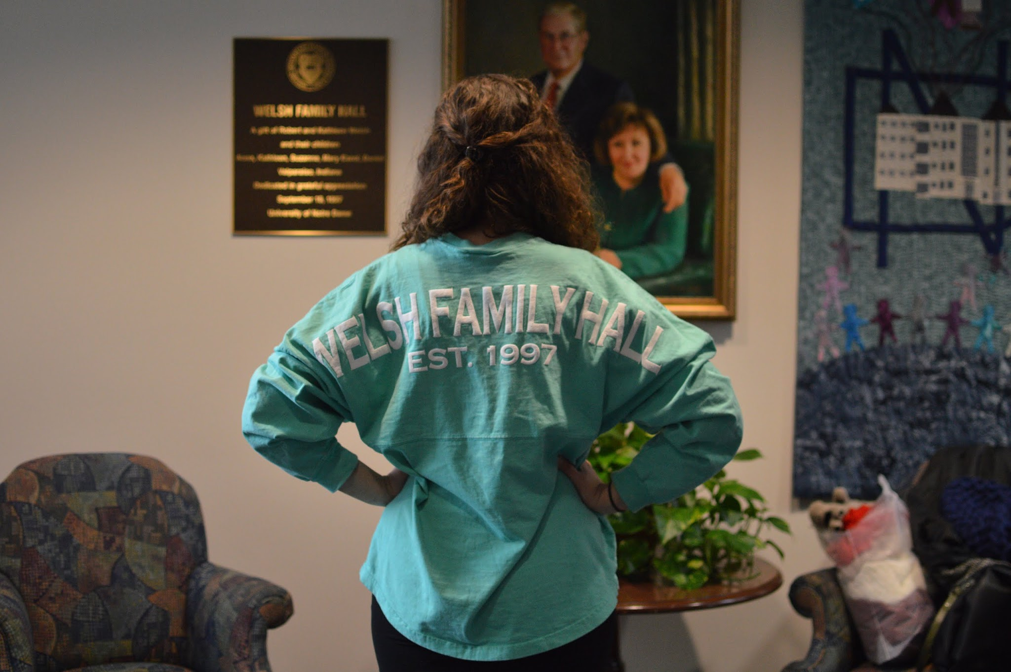(DSC_1469)

Mr. and Mrs. Welsh approve.

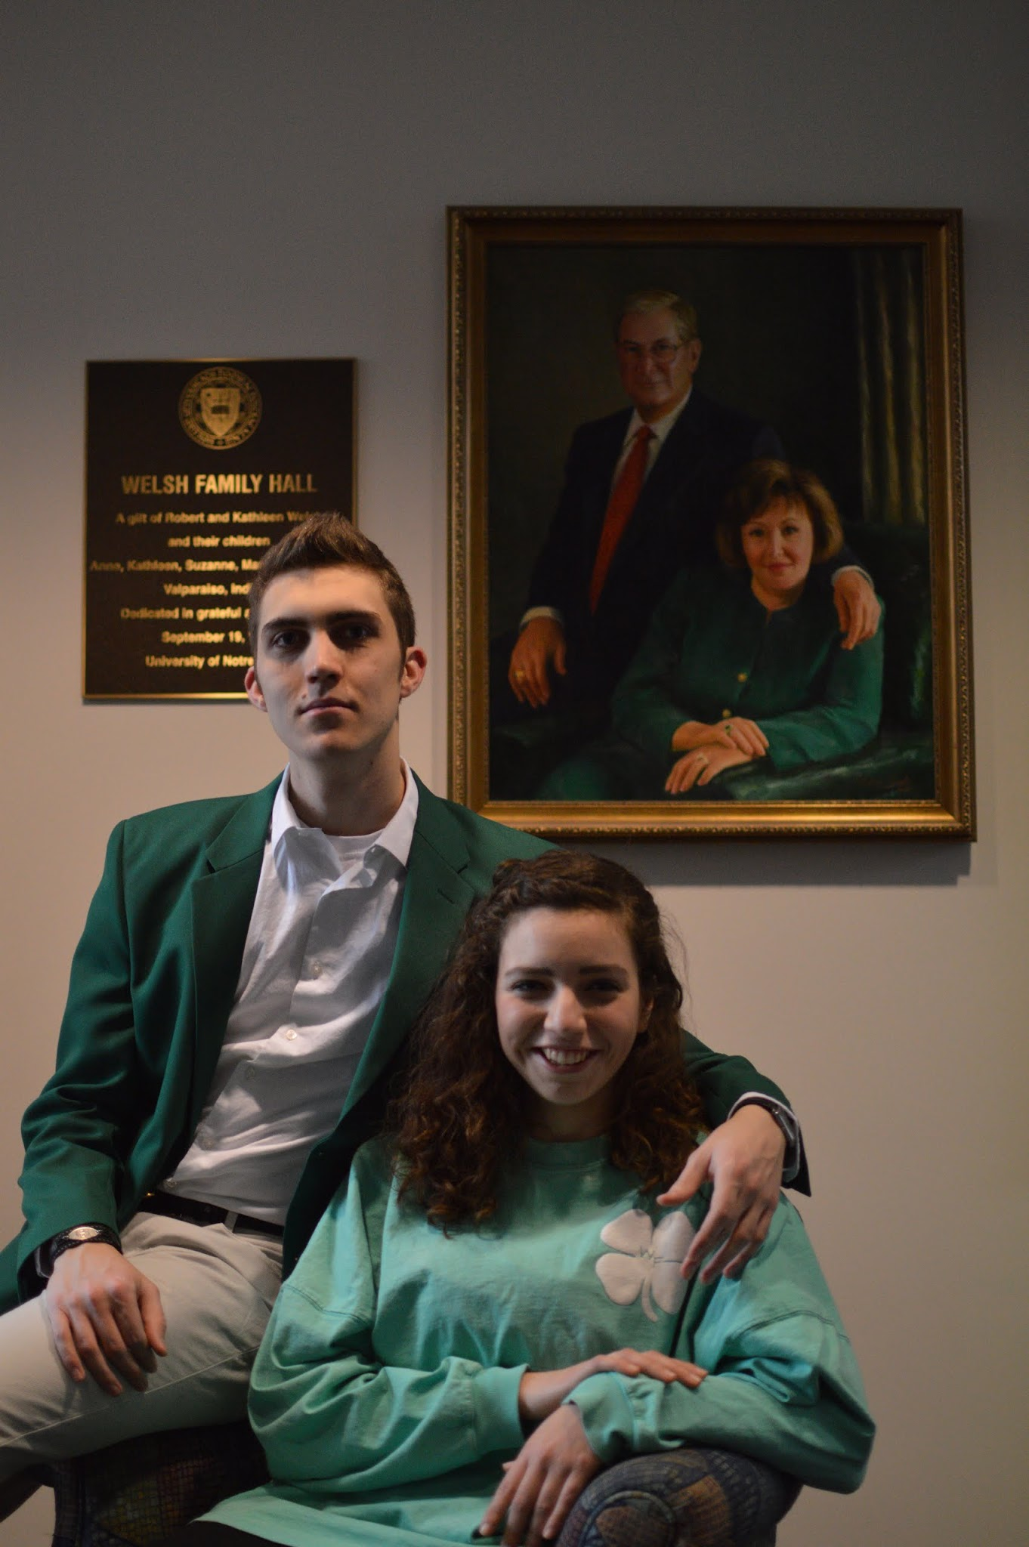 (DSC_1463)

**Day 7 (Monday):**

*FACEBOOK:*

9:30 PM

Our #MCM is Bryan Ricketts! Did you know our tie-loving president was once featured in a fashion blog? Check it out <http://www.itsnaynaynaynay.com/prism.html>

 (BryanMCM)

5:30 PM

With experience in Diversity Council, our team wishes to collaborate with student clubs and organizations on campus to foster cooperation and unity within the student body. #RickettsRuelas2015

9:00 PM

Myth: There are printers in 24 hour spaces in every dorm on campus.

Fact: Most dorms' printers are actually unavailable to members of the opposite sex after parietals. #RickettsRuelas2015

How can we collaborate and learn together when dorm study spaces are unavailable after parietals? We hope to ensure that each dorm has a printer that is located in a 24 hour space so that late night study sessions never have to be interrupted. #RickettsRuelas2015

*TWITTER:*

11 AM

Our #MCM is Bryan! Look for him around campus today! #RR2015

 (BryanMCM)

6PM

@WelshFam, Nidia would say she is a #Whirlwind, but she’d be Lyon! Even though she moved out of WF this semester, she will be back tonight!

6 PM

Ready for a special appearance by your favorite Highlander, @ND_DuncanHall? Bryan returns home tonight to talk about the platform! #RR2015

8PM

The debate is tonight! Come to LaFun at 9PM to hear about our ideas! We will be live-tweeting the event using #RRDebate!

8:45PM

We are busy getting ready for the debate! Hope to see you there! #RRDebate

9PM

Debate just starting! Are you in the audience? #RRDebate

*INSTAGRAM:*

Our #MCM is Bryan Ricketts! Be on the lookout for him at the debate tonight!

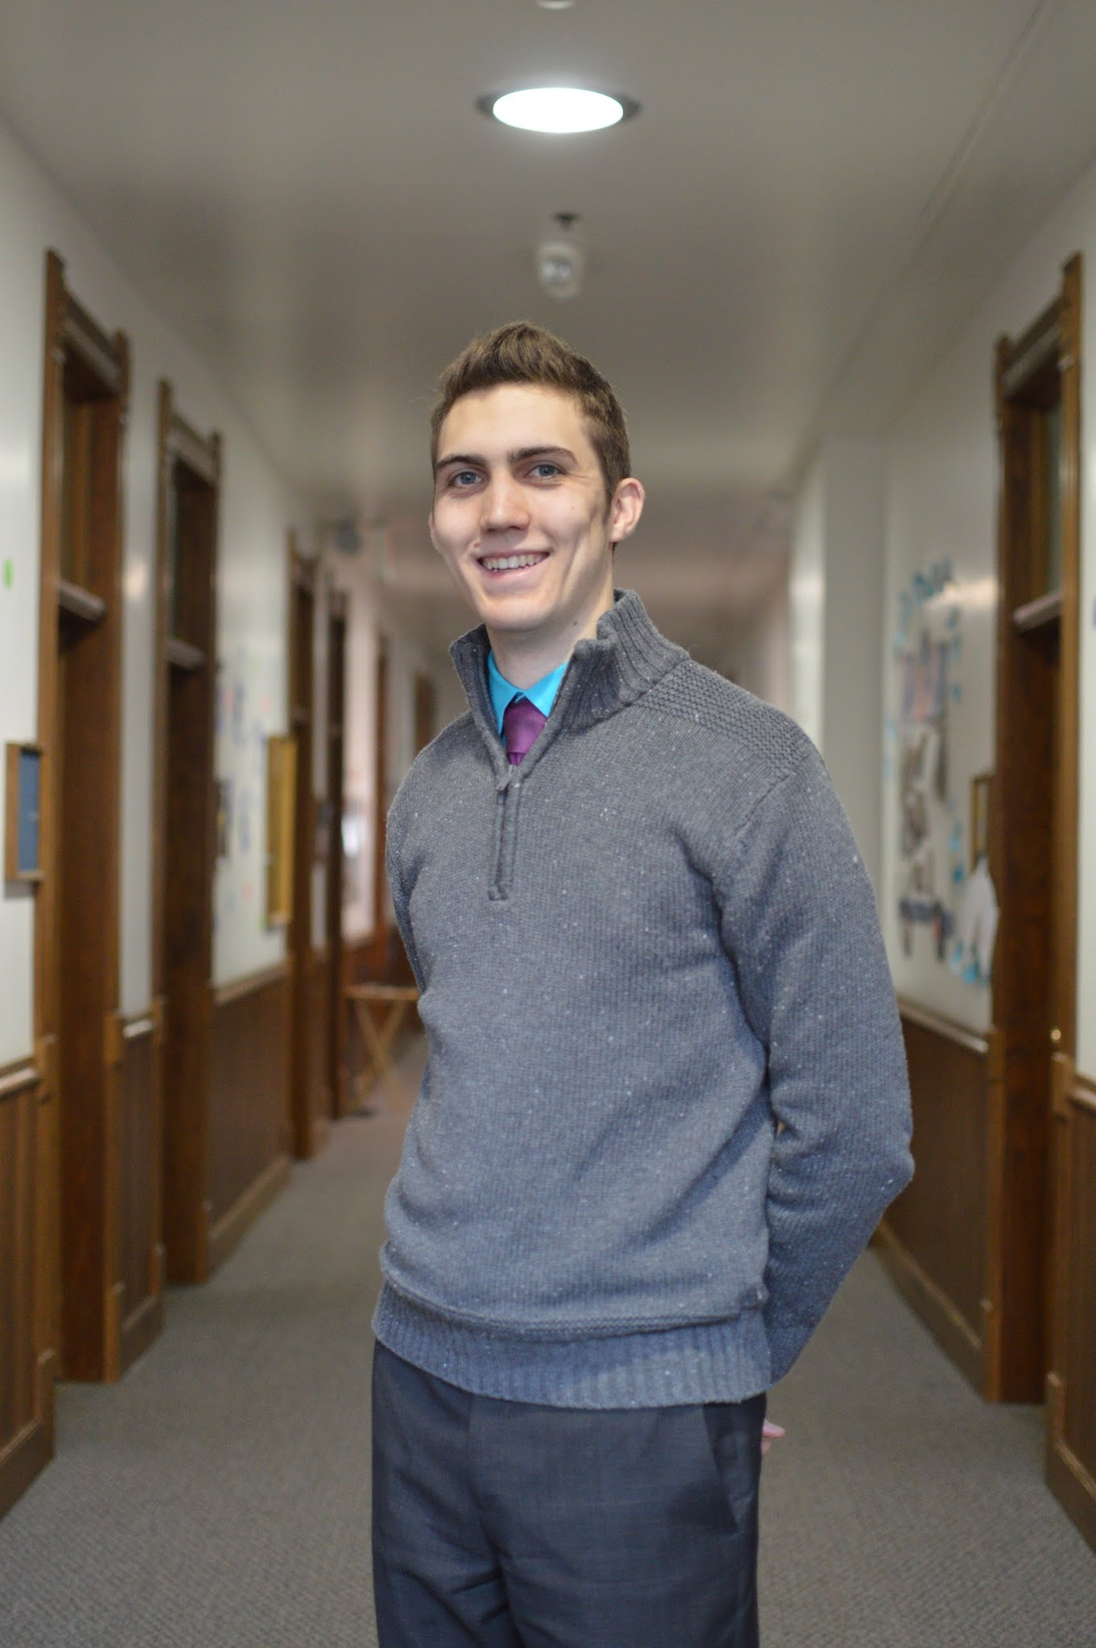 (DSC_1641)

**Day 8 (Tuesday):**

*FACEBOOK:*

9:30 AM

What part of your #Identity would you like to celebrate? Let us know! #RickettsRuelas2015

12:00 PM

Mental health is important for everyone during the stressful college years, which is why we support the continuation of Irish State of Mind Week.#RickettsRuelas2015

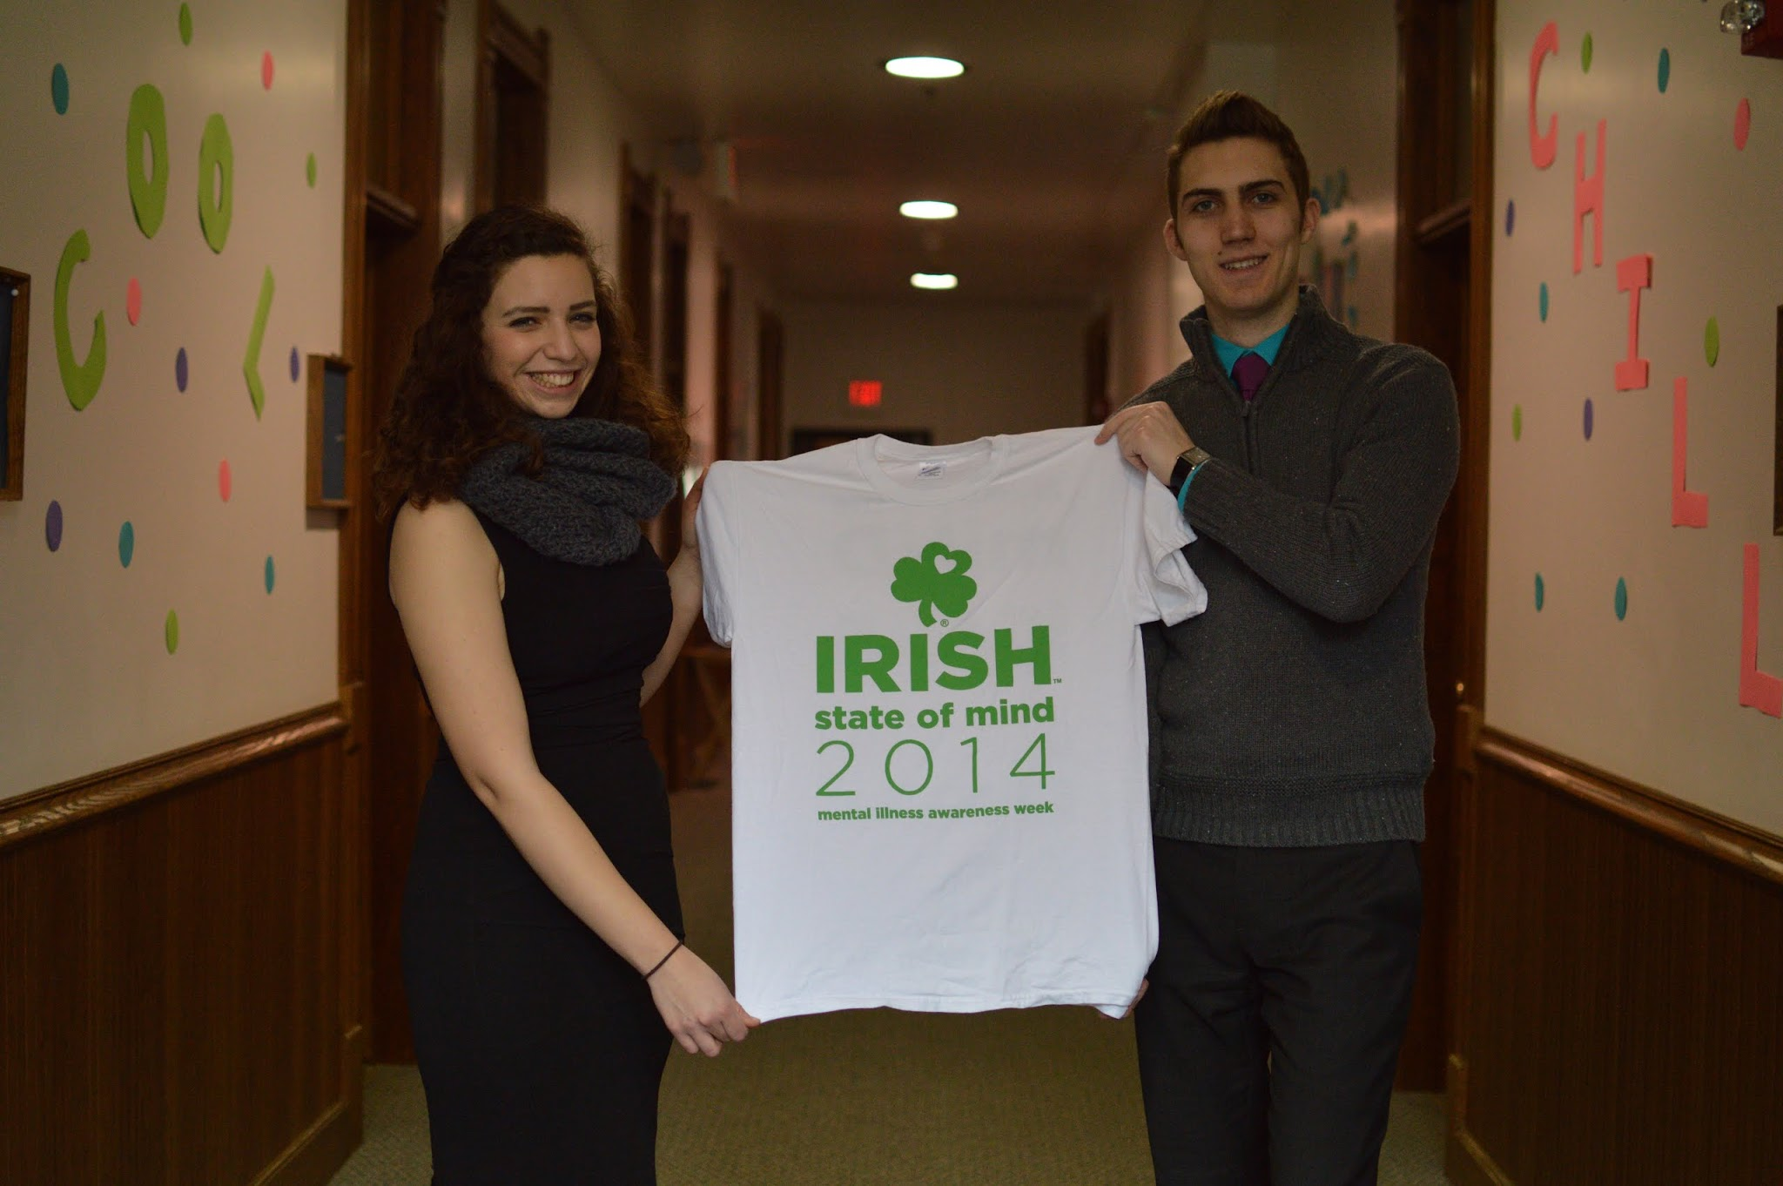 (DSC_1614)

8:00 PM

T-12 hours! We’ve had a great week meeting with each of you, and hope you’ve enjoyed meeting with us as well! Voting begins tomorrow at 8AM until 8PM, so be sure to check your inboxes! #RickettsRuelas2015

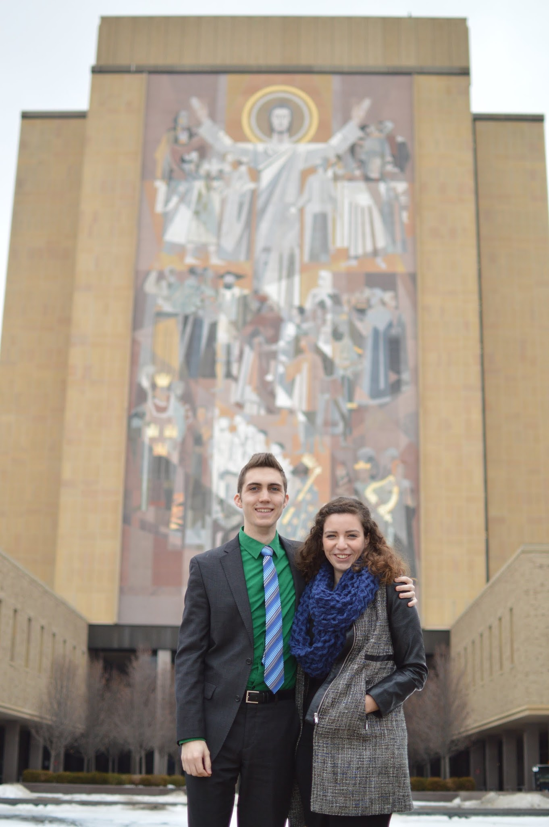(DSC_1878)

*TWITTER:*

10AM

Share with us a part of your #Identity that you’d like to celebrate! #RR2015

1:30PM

Let's not only pray for sexual assault survivors when one is reported. We want to spark a culture change by praying for healing all year.

4:30PM

The CSC does great work living out the call to social justice. We intend to support the initiatives of the CSC and promote opportunities.

6:30 PM

@FisherHallND, Bryan is stopping by tonight to share his excitement for the Regatta (#81days) and answer any questions you may have! #RR2015

8PM

12 more hours until voting opens! Make sure to check your email tomorrow morning and Vote Ricketts-Ruelas 2015! #RR2015

 (DSC_1878)

*INSTAGRAM:*

We support every student expressing their #Identity at Notre Dame. What’s yours?

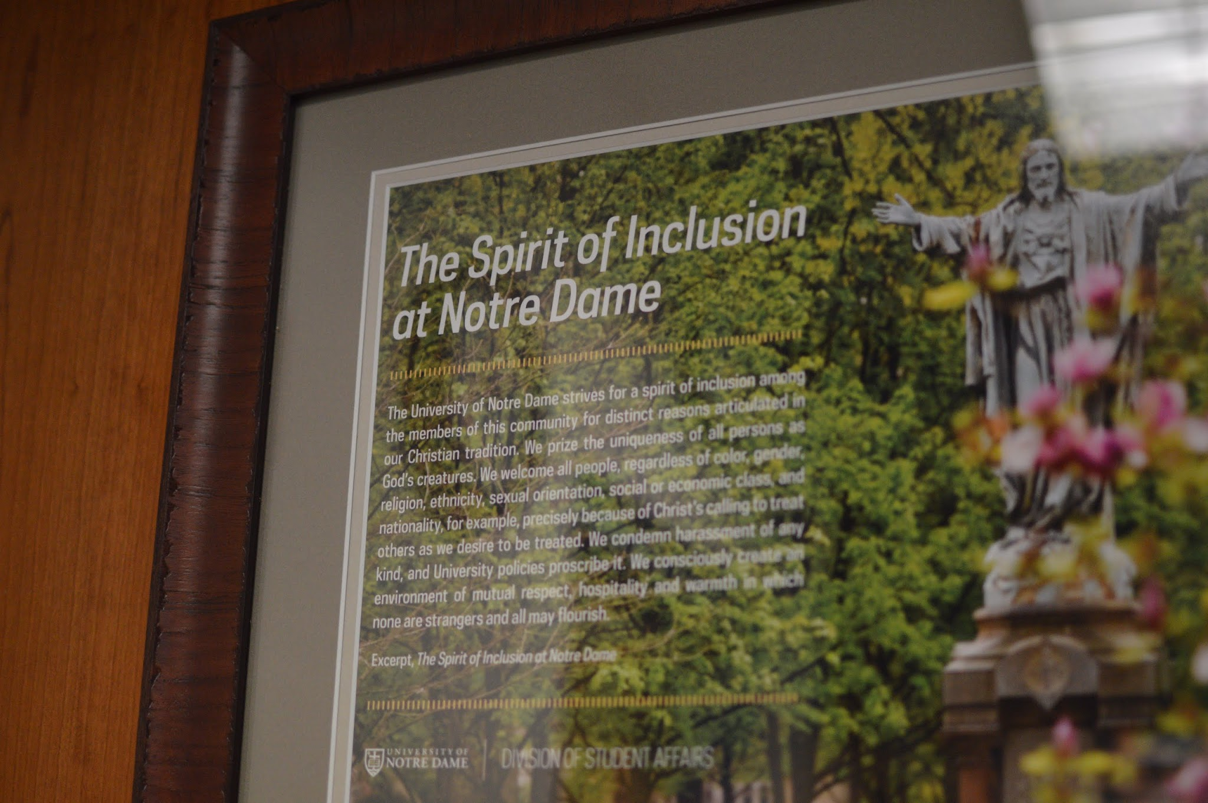 (DSC_1476)

And that’s a wrap on our dorm visits! It’s been great meeting each of you over this past week!

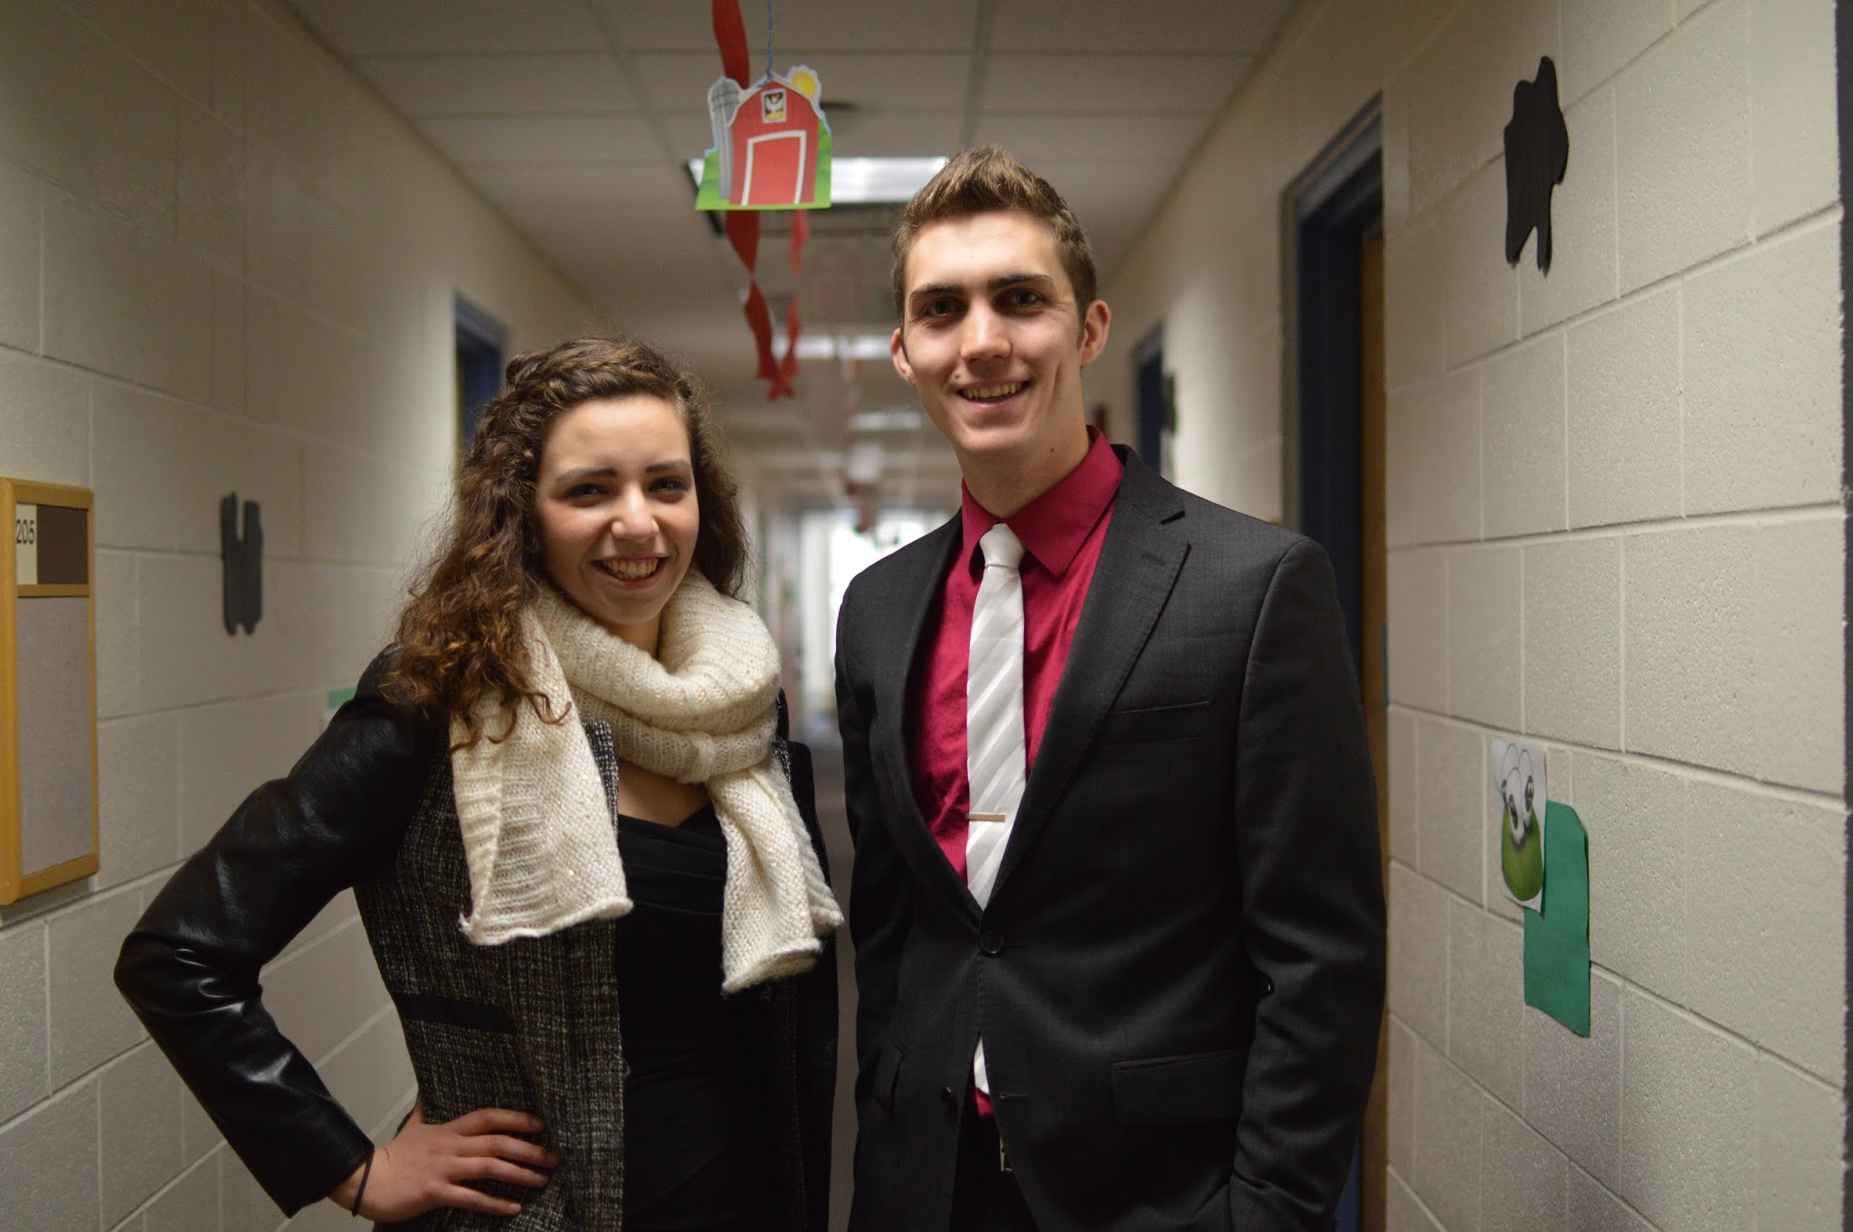 (DSC_1485)

**Election Day (Wednesday):**

*FACEBOOK:*

Event: 8am-8pm

Vote Ricketts-Ruelas 2015

Friends, voting is open! Check your email or visit jcouncil.nd.edu/vote/ to vote for Bryan and Nidia! Let us know when you’ve voted using #ivotedRR #RickettsRuelas2015

8 AM

Voting is now open! Make sure to check your email or visit jcouncil.nd.edu/vote/! Let us know you voted using #ivotedRR! #RickettsRuelas2015

9:30 AM

Have a last-minute question or just want to chat? We’ll be in LaFun all day, or you can reach us by email or phone (check the website for contact info). And once you vote, let us know with #ivotedRR #RickettsRuelas2015

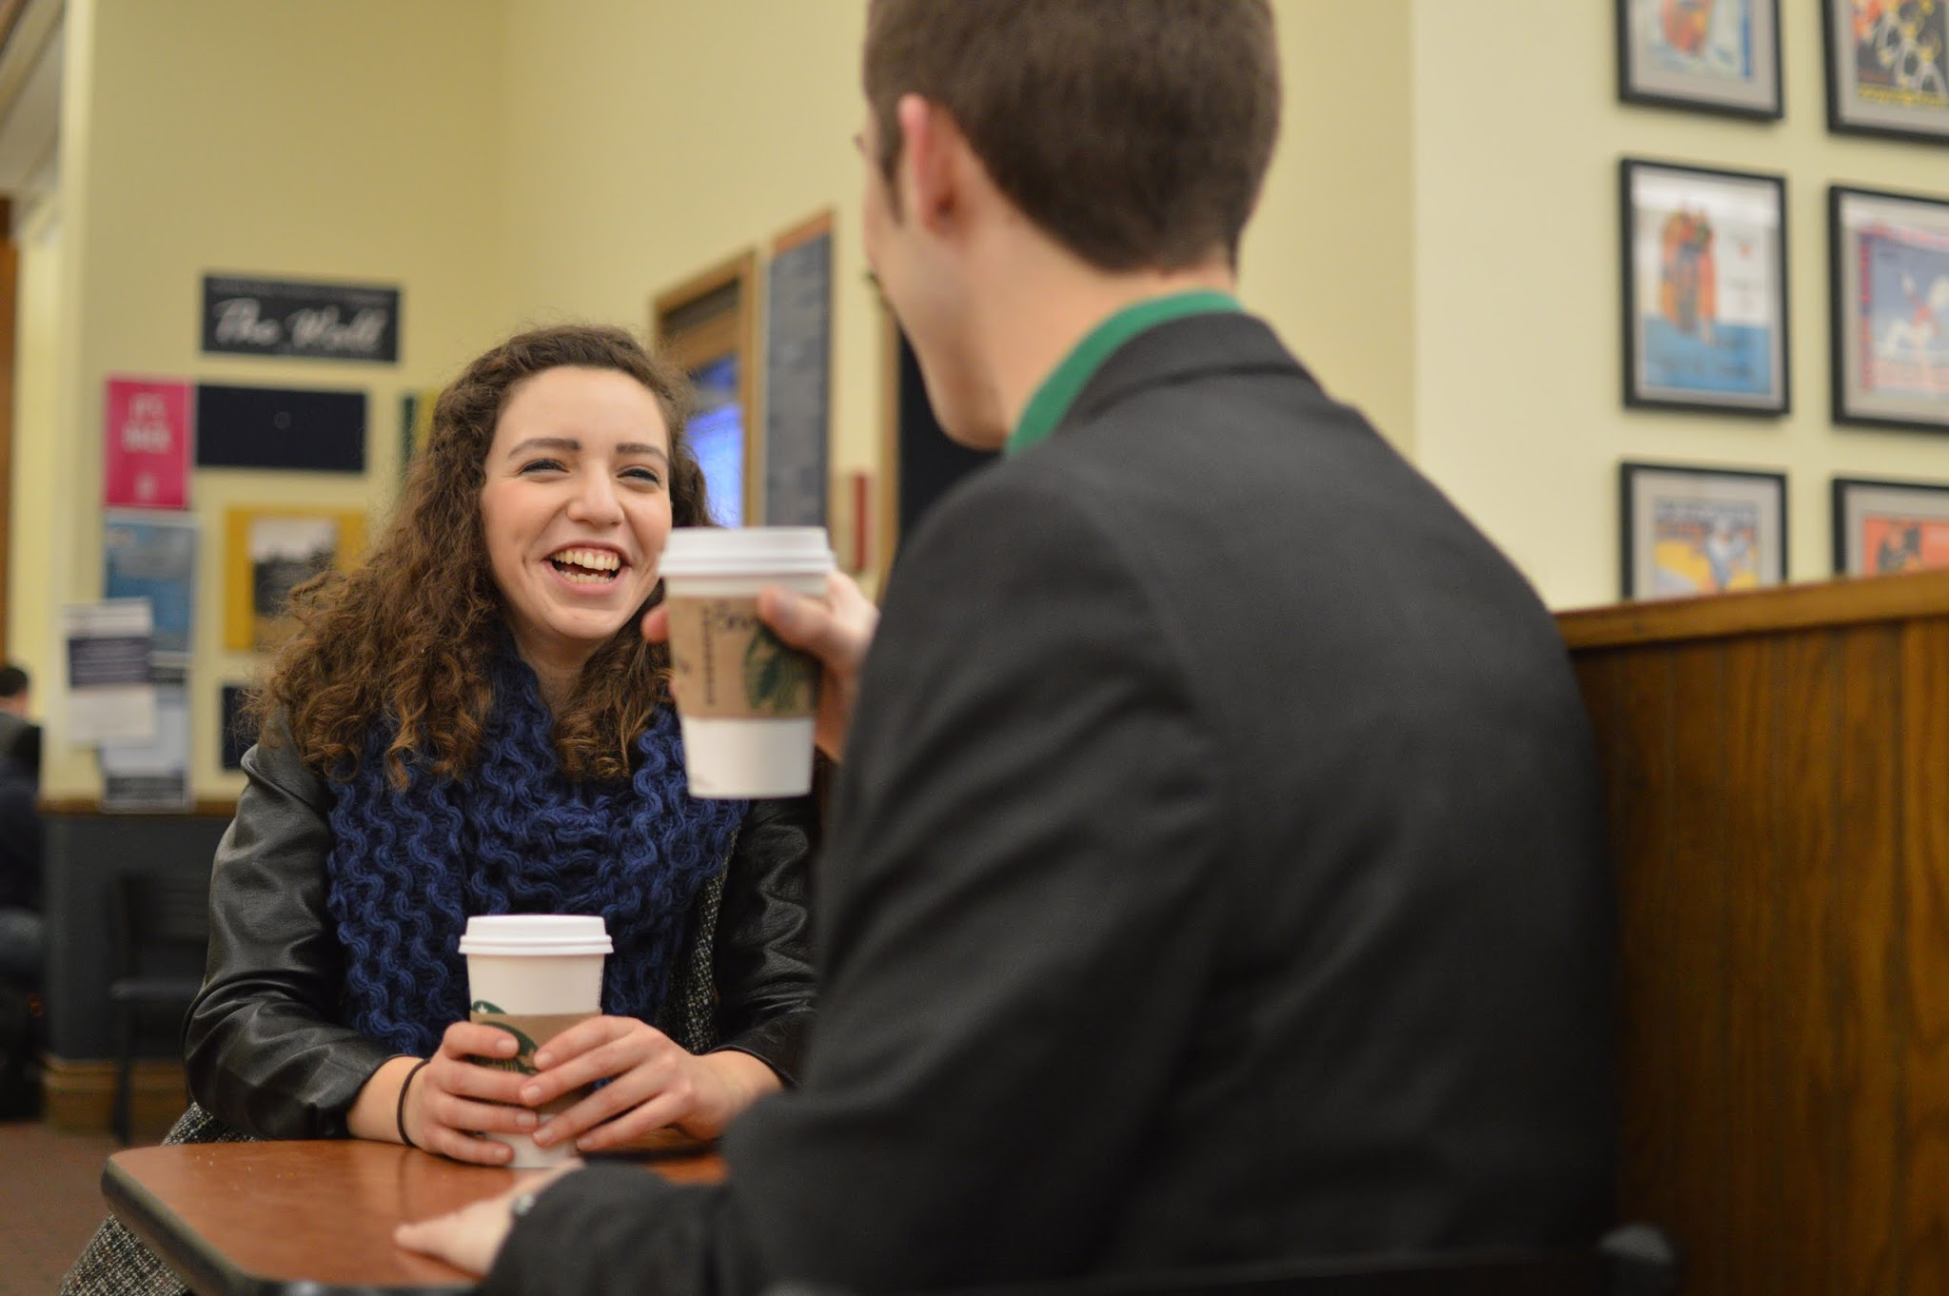(DSC_1798)

12 PM

Voting is still open for another 8 hours! Make your voice heard at ND by voting at jcouncil.nd.edu/vote/ and tell us about it with #ivotedRR #RickettsRuelas2015

3 PM

5 more hours to vote! Use #ivotedRR when you’re done! #RickettsRuelas2015

7 PM

Last hour to vote! We’d love your support in this election. Let us know you voted using #ivotedRR #RickettsRuelas2015

8 PM

Voting is now closed! Thanks to all those who have supported us throughout this process - we couldn’t have done it without you! Thanks also to Noemi Ventilla, Neil Joseph, and their team for a passionate and respectful campaign this past week. No matter the results, we’re looking forward to serving the students of Notre Dame in the coming year!

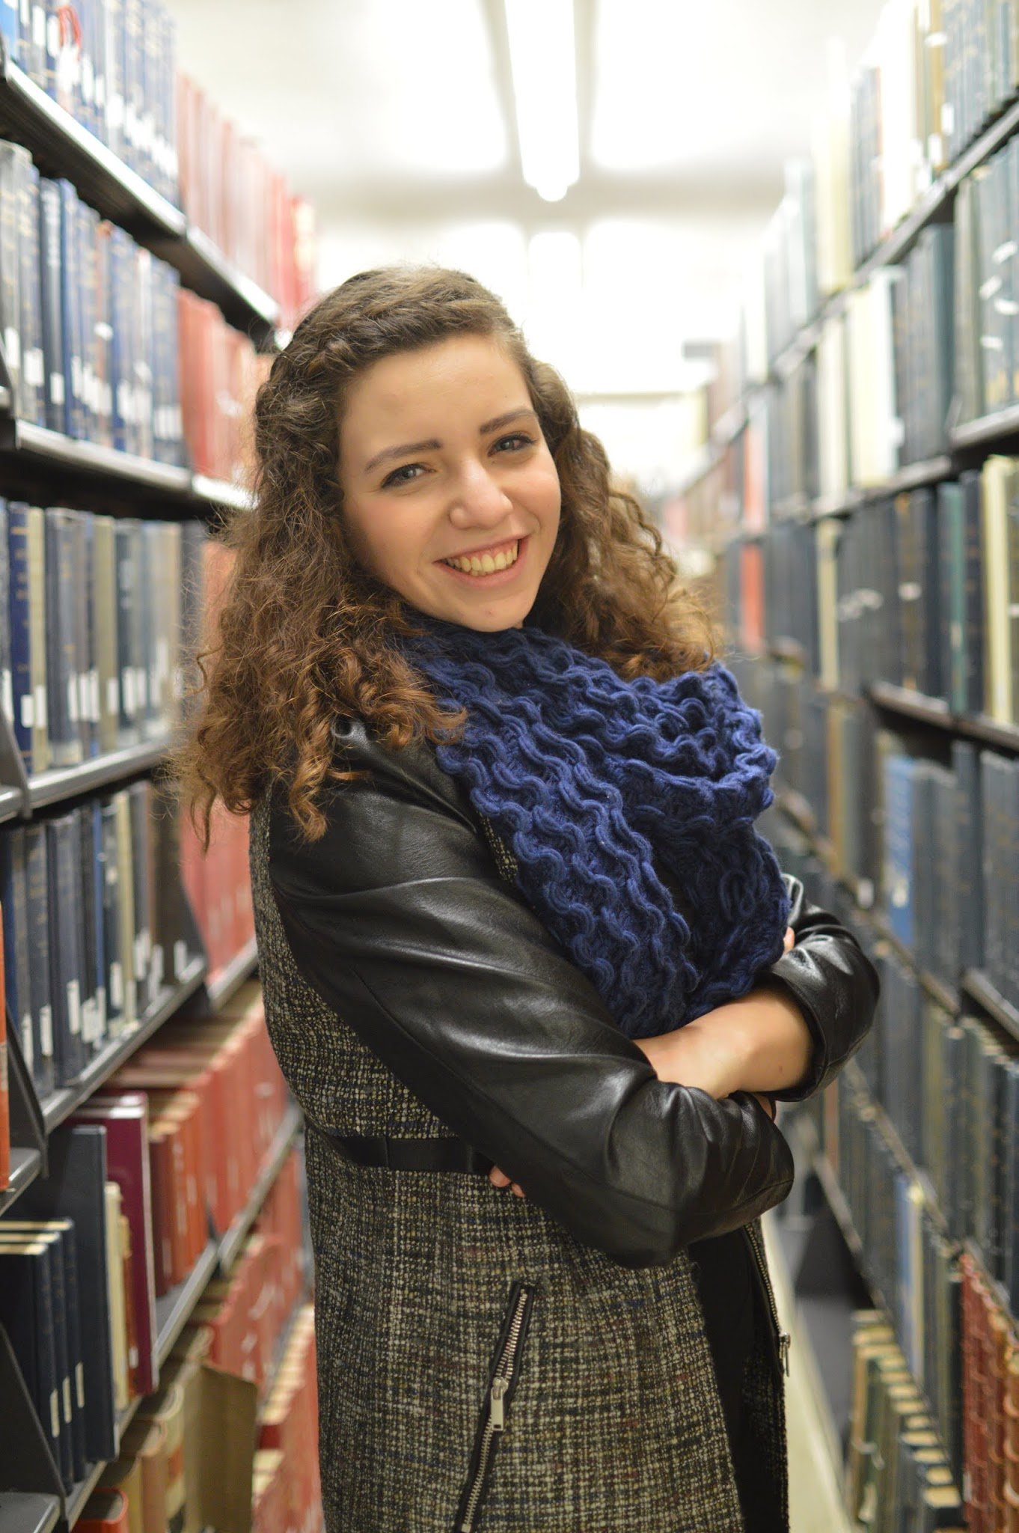(DSC_1851)

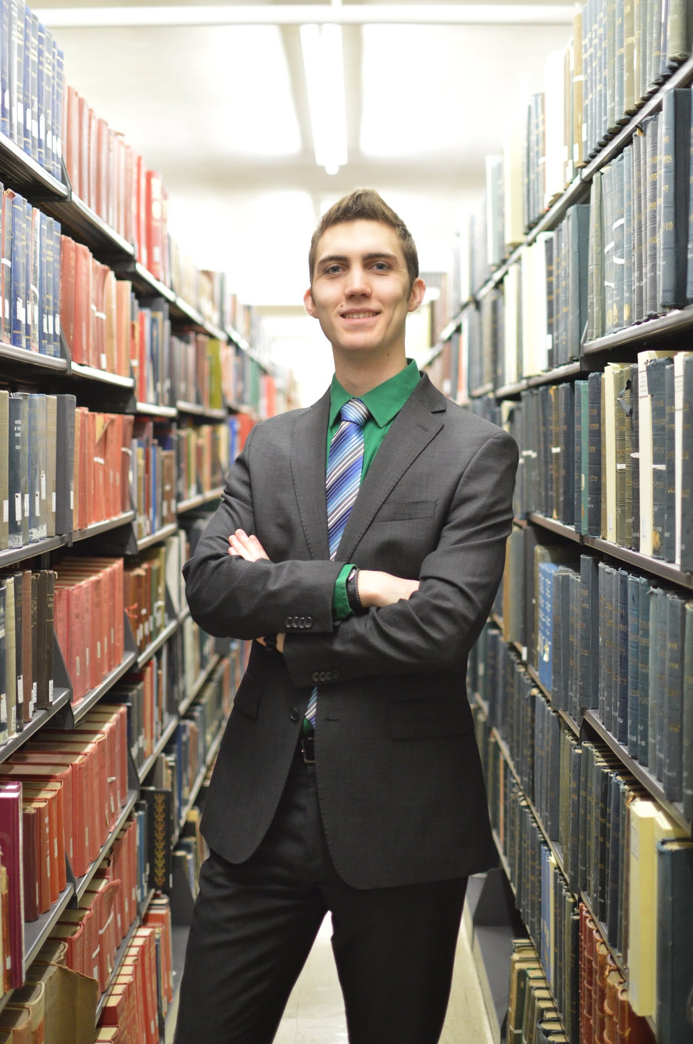(DSC_1860)

WE WIN

We’re happy to announce that your student body president & vice president for the 2015-16 term are Bryan Ricketts & Nidia Ruelas. A huge thank you to our campaign manager, Lily Crawford, the entire campaign team, and all those who voted for us. Looking forward to working to bring Passion, Unity, and Identity to the second floor of LaFortune!

WE LOSE

Congratulations to Noemi Ventilla and Neil Joseph! We are looking forward to your leadership for Notre Dame in the coming year. Thank you to our campaign manager, Lily Crawford, our dedicated team, and all of our supporters! Though it will not be us as President and VP, we will continue to look for ways to serve the Notre Dame community moving forward!

WE RUNOFF

The results are in and… We’re going for another round! Neither ticket achieved a majority, so we are headed to a runoff election on Monday, Feb. 9. Stay tuned for more updates!

*TWITTER:*

8 AM

It’s time to vote! Check your email or jcouncil.nd.edu/vote. Let us know you voted with #ivotedRR #RR2015

9:30 AM

Want to chat? Come to LaFun or reach us by email or phone (contact info on website). And let us know you voted with #ivotedRR #RR2015

12 PM

8 hours left to vote! Let your voice be heard, and then let us know using #ivotedRR #RR2015

3 PM

Only 5 more hours! If you haven’t voted yet, please go to jcouncil.nd.edu/vote, and then let us know with #ivotedRR #RR2015

7 PM

Last hour! Get those votes in by 8 PM and show us you voted with #ivotedRR #RR2015

8 PM

Polls are now closed! Thanks everyone for your work over the past week, and best of luck to Noemi and Neil as the votes are counted!

WE WIN

Proud to announce that Bryan Ricketts & Nidia Ruelas are your president and vice president for the 2015-16 term!

We would like to thank Noemi Ventilla and Neil Joseph for a passionate and respectful campaign this past week.

And a huge thank you to Lily Crawford, our campaign manager, to the campaign team, and to all of our supporters!

Looking forward to working to bring #Passion, #Unity, and #Identity to the second floor of LaFortune!

WE LOSE

Congratulations to Noemi Ventilla and Neil Joseph on their election! We would like to thank them for a passionate and respectful campaign this past week.

A huge thank you to Lily Crawford, our campaign manager, to the campaign team, and to all of our supporters!

Though it will not be as President and VP, we will continue to look for ways to serve the Notre Dame community moving forward!

WE RUNOFF

Results are in, and neither ticket achieved the majority… We’re headed to a runoff on Monday, Feb 9. Stay tuned for updates!

*INSTAGRAM:*

Bryan and Nidia have voted! Have you? Let us know using #ivotedRR